VITAELY-Full Stack Al SaaS App

A PROJECT REPORT

Submitted by

Niladri Banik (18771024011)
Anushka Roy (18771024005)
Supervised by

Prof. Sarasij Majumdar
in partial fulfillment for the award of the degree of
Masters of Computer Application

IN

Year: 2026


TECHNO INTERNATIONAL NEW TOWN
1/1, Service Rd, DG Block (Newtown), Action Area I, Newtown, West Bengal 700156

Certificate of Approval


This is to certify that the project report entitled Vitaely is a record of bona-fide work, carried out by Niladri Banik under the supervision and guidance of Prof. Sarasij Majumdar

The report in its present form is in conformity, as specified by the Techno International New Town and as per regulations of the Maulana Abul Kalam Azad University of Technology (formerly known as West Bengal University of Technology). To the best of our knowledge, the results presented here are original in nature and worthy of incorporation in the present version of the report for final year Major Project of Master of Computer Applications.

Guide/Supervisor Head of the Department

Prof. Sarasij Majumdar Dr. Soma Chatterjee
Department Of MCA Department of MCA
Techno International New Town Techno International New Town

Certificate of Approval

This is to certify that the project report entitled Vitaely is a record of bona-fide work, carried out by Anushka Roy under the supervision and guidance of Prof. Sarasij Majumdar

The report in its present form is in conformity, as specified by the Techno International New Town and as per regulations of the Maulana Abul Kalam Azad University of Technology (formerly known as West Bengal University of Technology). To the best of our knowledge, the results presented here are original in nature and worthy of incorporation in the present version of the report for final year Major Project of Master of Computer Applications.

Guide/Supervisor Head of the Department

Prof. Sarasij Majumdar Dr. Soma Chatterjee
Department Of MCA Department of MCA
Techno International New Town Techno International New Town

TABLE OF CONTENTS

CHAPTER NO. | TITLE | PAGE NO.
 | ACKNOWLEDGEMENT ABSTRACT  LIST OF SYMBOLS, ABBREVIATIONS  AND NOMENCLATURE | i  ii  iii

- PROJECT PLANNING AND SCHEDULING | 4-8
  - Introduction to Project Planning 4
  - Importance of Scheduling in Software Projects 4
  - Gantt Chart 5-6
    - Activities Included in the Gantt Chart 5
    - Description of the Gantt Chart 6
  - PERT Chart 7-8
    - Description of the PERT Chart 8
- INTRODUCTION | 9-12
  - Background of the Study 9
  - Motivation for the Project 9
  - Problem Statement 10
  - Objectives of the Project 11
  - Scope of the Project 12
  - Organization of the Report 12
- LITERATURE SURVEY | 13-21
  - Introduction 13
  - Overview of AI in Content Creation 14
  - Conceptual Flow Diagram 15
  - Review of Existing AI & SaaS-Based Content Creation Tools 16-17
  - Comparative Analysis of Existing Systems 18
  - Comparative Positioning Diagram 19
  - Drawbacks of Existing AI and SaaS Tools 20

  - Research Gap 21
  - Summary of Literature Survey 21
- SYSTEM ANALYSIS | 22-32
  - Existing System 22
  - Block Diagram and ER diagram 23
  - Proposed System 24
  - Feasibility Study 25-26
    - Technical Feasibility 25
    - Economic Feasibility 25
    - Operational Feasibility 26
  - Requirement Analysis 27
    - Functional Requirements 27
    - Non-Functional Requirements 27
  - Use Case Diagram 28
  - Data Flow Diagrams (DFD) 29-31
    - DFD Level 0 29
    - DFD Level 1 (0.1) 30
    - DFD Level 1 (0.2) 31
  - Summary of System Analysis 32
- SYSTEM DESIGN | 33-41
  - Introduction to System Design 33
  - Design Goals and Principles 34
  - Overall System Architecture 35
  - Architectural Diagram Explanation 36
  - Detailed Module Design 37-38
    - User Authentication and Authorization Module 37
    - PDF to Word Converter Module 37
    - Portfolio Website Generator Module 37
    - Dashboard & Content Management Module 38
    - Administrative & Monitoring Module 38
  - Module Interaction Diagram 39
  - API Design 40
  - Database Design 40
  - Frontend Design and User Interface 40
  - Security Design & Data Protection 40-41
  - Scalability, Reliability & Performance Design 41
  - Summary of System Design 41
- SYSTEM IMPLEMENTATION | 42-66
  - Introduction to Implementation 42
  - Technology Stack Used 43-44
  - Backend Implementation 45-55
    - Server Setup and Configuration 45
    - User Authentication Implementation 45-46
    - AI Image Generation Implementation 47-51
    - AI Blog Title Generation Implementation 52-55
  - Frontend Implementation 56-65
    - UI Design Implementation 56-61
    - Dashboard Implementation 62-64
    - API Integration 65
  - Database Implementation 65
  - Integration of Modules 65
  - Deployment Implementation 65
  - Implementation Challenges & Solutions 66
  - Summary of Implementation 66
- TESTING AND RESULTS | 67-75
  - Introduction to System Testing 67
  - Testing Objectives 67
  - Testing Strategy 67
  - Types of Testing Performed 68
    - Unit Testing 68
    - Integration Testing 68
    - System Testing 68
    - User Acceptance Testing (UAT) 68
  - Test Case Design 68-69
  - Functional Testing Results 69
  - Performance Testing 69
  - Security Testing 69
  - Usability Testing 70
  - Result Analysis 70
  - Output Screenshots 71-74
  - Limitations Observed During Testing 75
  - Summary of Testing and Results 75
- CONCLUSION AND FUTURE SCOPE | 76-84
  - Project Summary 77
  - Achievement of Project Objectives 78
  - Evaluation of System Performance 79
  - Learning Outcomes and Technical Insights 80
  - Limitations of the System 81
  - Future Scope and Enhancements 82
  - Social and Educational Impact 83
  - Conclusion 84
- REFERENCES | 85

I would like to express my sincere gratitude to my project guide Prof. Sarasij Majumdar, for his invaluable guidance, constant encouragement, and constructive suggestions throughout the development of this project. Their support and expertise played a crucial role in the successful completion of this work.

I am also thankful to the Head of the Department, Department of Masters of Computer Applications, and all faculty members for providing the necessary academic environment, resources, and support required to carry out this project effectively.

I would like to extend my heartfelt thanks to the management of Techno International New Town for providing the infrastructure and facilities that enabled me to complete this project successfully.

I am deeply grateful to my parents and family members for their continuous motivation, encouragement, and moral support throughout my academic journey. I also thank my friends and classmates who provided valuable suggestions and assistance during the course of this project.

Finally, I thank everyone who directly or indirectly contributed to the successful completion of this project.

Niladri Banik
Anushka Roy

In today's competitive job market, students and professionals often face challenges in creating effective resumes, preparing for interviews, identifying skill gaps, and staying informed about industry trends. Existing solutions are often fragmented, requiring users to rely on multiple platforms for different career development needs. To address these challenges, Vitaely has been developed as an AI-powered Career Development SaaS platform that provides a centralized solution for career growth and employability enhancement.

Vitaely integrates several AI-driven features, including Resume Builder, Cover Letter Generator, Interview Preparation, ATS Score Checker, Skill Gap Analyzer, Industry Insights, Portfolio Website Generator, AI Email Writer, and a Research & Publication Hub. The platform also offers document utilities such as PDF-to-Word conversion, Word-to-PDF conversion, and PDF compression. By leveraging Artificial Intelligence through the Gemini API, the system delivers personalized recommendations, automated content generation, and career-focused guidance.

The application is built using modern technologies such as React 19, Next.js 15, Tailwind CSS, NeonDB, Prisma ORM, Clerk Authentication, and ShadCN UI, ensuring scalability, security, and an intuitive user experience. The platform follows a modular SaaS architecture that supports efficient resource management and future expansion.
This project demonstrates the practical application of Artificial Intelligence in career development by simplifying professional growth activities and enhancing user productivity. Vitaely serves as an intelligent career companion that helps users improve employability, make informed career decisions, and prepare effectively for academic and professional opportunities.

AI – Artificial Intelligence
API – Application Programming Interface CRUD – Create, Read, Update, Delete JWT – JSON Web Token
NLP – Natural Language Processing REST – Representational State Transfer SaaS – Software as a Service
UI – User Interface
UX – User Experience

Introduction to Project Planning

Project planning is an essential activity in software engineering that ensures the successful completion of a project within the specified time, cost, and resource constraints. It involves defining project objectives, identifying tasks, allocating resources, and monitoring progress throughout the development process. For an AI-powered SaaS platform like Vitaely, proper planning is necessary to manage multiple modules, AI integrations, and modern web technologies efficiently.
In academic software projects, project planning demonstrates the application of software engineering and project management principles. Techniques such as Gantt Charts and PERT Charts help visualize project schedules, task dependencies, and milestones, ensuring systematic development and timely completion.

Importance of Scheduling in Software Projects

Scheduling is the process of organizing project activities and assigning time estimates to each task. A well-planned schedule helps track progress, manage resources effectively, and reduce the risk of delays.
For the Vitaely project, scheduling was important for managing phases such as requirement analysis, system design, AI integration, frontend and backend development, testing, deployment, and documentation. Proper scheduling ensured the timely development of all features and successful completion of the project within the academic timeline.

A Gantt chart is a project management tool used to represent project activities along a timeline. It shows the start and end dates of tasks, their duration, and the overall project schedule. Gantt charts help in tracking progress, managing deadlines, and ensuring the timely completion of project activities.

For the Vitaely project, the Gantt chart was used to plan and monitor different phases of development. It provided a clear view of task sequencing, dependencies, and project milestones throughout the development lifecycle.

Activities Included in the Gantt Chart

The major activities represented in the Gantt chart include:
- Requirement Analysis and System Planning
- UI/UX Design and Frontend Development
- Database Design and Backend Development
- Gemini AI Integration and Feature Implementation
- Testing, Debugging, and Performance Optimization
- Deployment and Documentation
Each activity was assigned an estimated duration based on its complexity and importance. Some tasks were carried out simultaneously to ensure efficient utilization of time and successful project completion within the academic schedule.

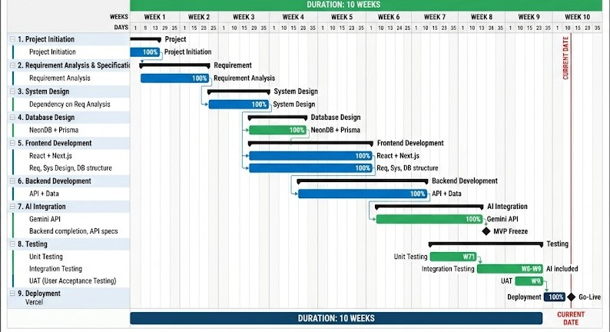
GANTT CHART

Description of the Gantt Chart

The above figure illustrates the Gantt chart for the Vitaely project. The horizontal axis represents the project timeline, while the vertical axis lists the major project activities. The bars indicate the duration allocated to each task and show how the project progressed through different development phases.
The chart provides a clear overview of activities such as planning, design, development, AI integration, testing, deployment, and documentation. It helped in tracking project progress, managing deadlines, and ensuring the successful completion of the project within the stipulated academic timeline.

PERT CHART

The Program Evaluation and Review Technique (PERT) is a project management tool used to represent task dependencies and the flow of activities within a project. Unlike Gantt charts, which focus on schedules and timelines, PERT charts emphasize the sequence of tasks and help identify the critical path of the project.

For the Vitaely project, the PERT chart was used to visualize the relationship between different development phases and ensure smooth project execution.

The PERT chart helped in identifying:

- Sequential and parallel activities
- Task dependencies
- Critical path activities
- Major project milestones
By identifying the critical path, the project development process was managed more effectively, reducing delays and ensuring the timely completion of key modules such as AI integration, resume building, interview preparation, and other career development features.

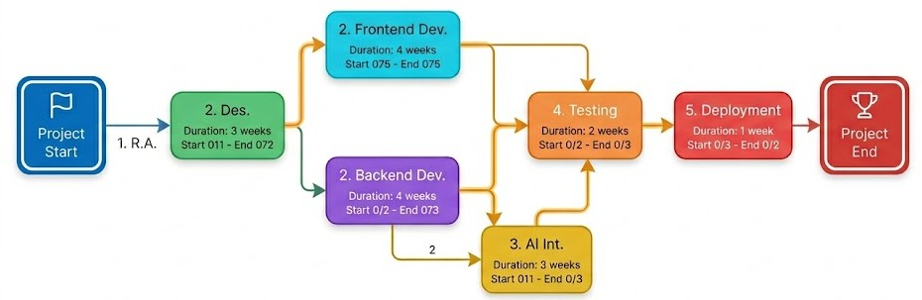
PERN CHART

Description of the PERT Chart

The above figure represents the PERT chart for the Vitaely project. Each node represents a project activity, while the connecting arrows indicate the dependencies between tasks. The chart begins with requirement analysis and planning, followed by design, development, AI integration, testing, deployment, and documentation phases.

The PERT chart illustrates the logical flow of activities and highlights the critical tasks that directly influence the project completion time. It also identifies activities that can be performed simultaneously, enabling efficient resource utilization and smoother project execution.

Background of the Study

In today's competitive job market, students and professionals require effective tools for resume building, interview preparation, skill development, and career planning. However, many existing solutions are fragmented and require the use of multiple platforms. Advances in Artificial Intelligence (AI) and Software as a Service (SaaS) have made it possible to provide personalized and automated career guidance through a single platform.
Vitaely is an AI-powered career development platform designed to help users improve employability, enhance professional profiles, and make informed career decisions through intelligent automation.

Motivation for the Project

The motivation behind Vitaely is to simplify career development by providing essential tools such as resume building, interview preparation, ATS analysis, skill gap identification, and industry insights in one platform. The project also offers practical experience in AI integration, full-stack development, and modern SaaS application design while addressing real-world career challenges.

Despite the availability of various career development platforms, students and professionals often rely on multiple tools for resume building, interview preparation, skill assessment, career guidance, and document management. This fragmented approach leads to inefficiency, increased effort, and a lack of personalized support.

Therefore, there is a need for a unified AI-powered platform that provides comprehensive career development services through a single, user-friendly interface.

Vitaely addresses this problem by integrating AI-driven features such as Resume Builder, Cover Letter Generator, Interview Preparation, ATS Score Checker, Skill Gap Analyzer, Industry Insights, and Research & Publication Support into a centralized SaaS platform, enabling users to enhance their employability and career growth efficiently.

The primary objectives of the Vitaely project are:

- To develop an AI-powered career development platform that assists users in professional growth.

- To provide intelligent resume building and cover letter generation features.

- To offer AI-based interview preparation, ATS score analysis, and skill gap assessment.

- To deliver personalized industry insights and career recommendations.

- To design a responsive and user-friendly interface using React, Next.js, and Tailwind CSS.

- To implement secure authentication and scalable database management.

- To deploy the application as a cloud-based SaaS platform accessible from anywhere.

The scope of Vitaely includes AI-powered career development features such as resume building, cover letter generation, interview preparation, ATS score analysis, skill gap assessment, industry insights, portfolio generation, AI email writing, and research assistance. The platform also provides document management tools including PDF conversion and compression services.
The system is designed as a web-based SaaS application for students, job seekers, professionals, and researchers. Advanced features such as enterprise recruitment integration, mobile applications, and real-time job placement services are beyond the current scope and may be considered for future enhancements.

ORGANIZATION OF THE REPORT

This report is organized into multiple chapters covering the planning, analysis, design, implementation, testing, and evaluation of the Vitaely platform. Each chapter presents different aspects of the project in a systematic manner, supported by relevant diagrams, tables, and technical descriptions to provide a clear understanding of the system development process.

Introduction

The literature survey is an important part of the project as it helps in understanding existing research, technologies, and systems related to career development and Artificial Intelligence. It provides insights into how AI, SaaS platforms, and modern web technologies are being used to improve employability, career guidance, and professional growth.

In recent years, AI-powered career platforms have gained significant popularity by assisting users with resume creation, interview preparation, skill assessment, and career planning. While these platforms offer useful services, many of them provide limited functionality or require users to rely on multiple applications for different career-related needs. This creates inefficiencies and reduces user convenience.

This chapter reviews existing studies and systems in the field of AI-driven career development to identify their strengths and limitations. The findings help justify the need for Vitaely, a unified AI-powered SaaS platform that integrates multiple career enhancement tools into a single user-friendly solution.

Artificial Intelligence (AI) has significantly transformed the field of career development by enabling intelligent systems to automate tasks such as resume analysis, interview preparation, skill assessment, and personalized career guidance. Technologies such as Machine Learning (ML) and Natural Language Processing (NLP) help analyze user profiles, identify skill gaps, and generate relevant recommendations.

AI-powered career platforms can provide personalized insights, automate document creation, and improve decision-making for students and professionals. These technologies help users enhance their employability while reducing the time and effort required for career planning.

Despite these advantages, many existing career development platforms offer limited features or require users to use multiple tools for different purposes. This creates a need for integrated solutions like Vitaely, which combines various AI-powered career services into a single platform.

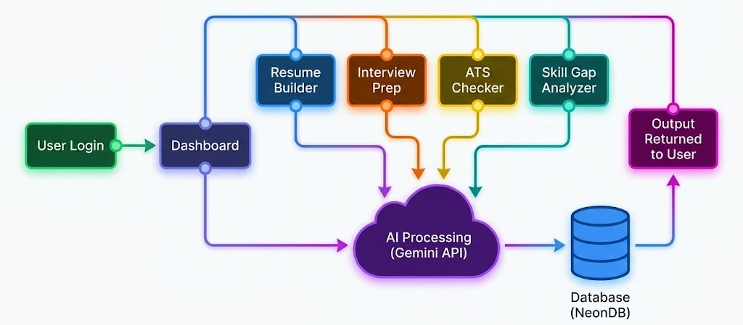

The rapid growth of Artificial Intelligence and cloud computing has led to the development of various career development and employability platforms. These systems assist users with tasks such as resume creation, interview preparation, skill assessment, and career planning. While these platforms provide valuable services, they often focus on specific functionalities rather than offering a complete career development solution.
AI-powered resume builders help users create professional resumes, while interview preparation platforms provide practice questions and feedback. Similarly, career guidance tools offer industry insights and skill recommendations. However, users frequently need to switch between multiple applications to access these services, resulting in fragmented workflows and reduced efficiency.
Many existing platforms also limit advanced features through premium subscriptions, making them less accessible to students and fresh graduates. Additionally, the lack of integration between career-related services often affects user convenience and productivity.
These limitations highlight the need for a unified AI-powered platform that combines resume building, interview preparation, ATS analysis, skill gap identification, industry insights, and research assistance within a single system. Vitaely addresses this need by providing an integrated, user-friendly, and scalable SaaS solution for career development and professional growth.

A comparative analysis of existing career development platforms highlights their strengths and limitations. Many platforms focus on specific functionalities such as resume building, interview preparation, job searching, or skill assessment. As a result, users often need to switch between multiple tools to meet their career development needs.
While AI-powered platforms provide automation and personalized recommendations, many advanced features are restricted by premium subscriptions. Additionally, the lack of integration between different career services can reduce efficiency and user convenience.

In contrast, Vitaely combines multiple AI-powered career development tools within a single SaaS platform. By integrating resume building, interview preparation, ATS analysis, skill gap assessment, industry insights, research assistance, and document management features, Vitaely offers a comprehensive, accessible, and user-friendly solution. This comparative analysis justifies the need for an integrated platform that balances functionality, usability, and affordability.

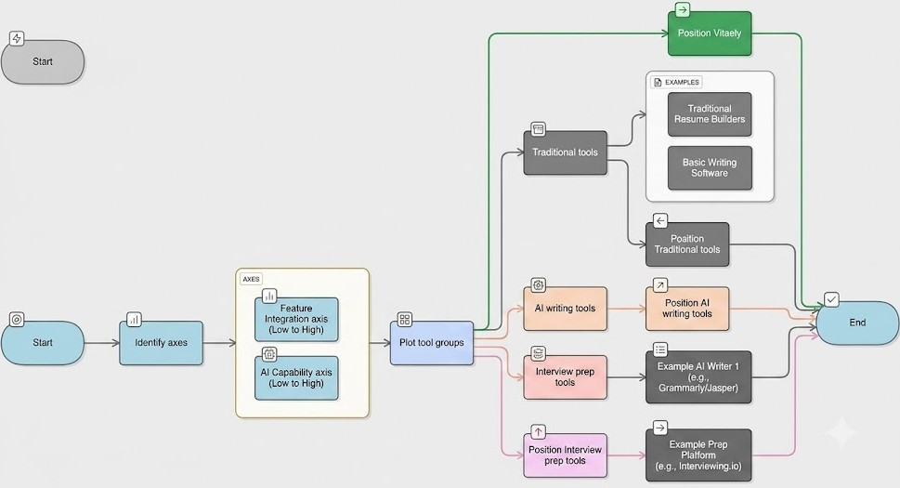

Despite the growing adoption of AI-powered career development platforms, several limitations still exist. A major drawback is the fragmentation of services, where users must rely on multiple platforms for resume creation, interview preparation, skill assessment, career guidance, and document management. This results in reduced efficiency and a less seamless user experience.

Additionally, many platforms restrict advanced features through costly subscription plans, making them less accessible to students and fresh graduates. Some systems also provide generic recommendations with limited personalization, reducing their effectiveness in addressing individual career goals.

These limitations highlight the need for an integrated, affordable, and user-friendly solution like Vitaely, which combines multiple career development services within a single AI-powered platform.

The literature review highlights a significant gap in the availability of integrated AI-powered career development platforms. Most existing systems focus on specific functionalities such as resume building, interview preparation, or career guidance, requiring users to depend on multiple applications to fulfill their professional development needs.

Additionally, many platforms offer limited personalization, restricted access to advanced features, or high subscription costs, making them less suitable for students and early-career professionals. There is a need for a unified, user-friendly, and affordable solution that combines multiple career enhancement services within a single platform.

This research gap motivates the development of Vitaely, which integrates AI-powered resume building, interview preparation, ATS analysis, skill gap assessment, industry insights, research assistance, and document management tools to provide a comprehensive career development ecosystem.

SUMMARY OF LITERATURE SURVEY

This chapter presented a review of existing literature and systems related to AI-powered career development platforms. The analysis examined the application of Artificial Intelligence in areas such as resume building, interview preparation, skill assessment, and career guidance, while identifying the strengths and limitations of current solutions.

Existing System

The existing career development ecosystem consists of multiple independent platforms that address specific needs such as resume building, interview preparation, job searching, skill assessment, and career guidance. Users often need to switch between different applications to access these services, resulting in fragmented workflows and reduced efficiency.

While many platforms provide useful features, they typically focus on a limited set of functionalities and lack seamless integration with other career development tools. AI-powered systems may offer resume analysis or interview assistance, but rarely provide a complete solution that supports the entire career growth process. This creates additional effort for users who must manage information across multiple platforms.

Another significant limitation is accessibility. Many advanced career development services are available only through premium subscriptions, making them less affordable for students and fresh graduates. In addition, some platforms offer generic recommendations with limited personalization based on individual skills, interests, and career goals.

These limitations highlight the need for an integrated, intelligent, and user-friendly platform. Vitaely addresses these challenges by combining AI-powered resume building, interview preparation, ATS analysis, skill gap assessment, industry insights, research assistance, and document management tools within a single SaaS-based environment.

BLOCK DIAGRAM

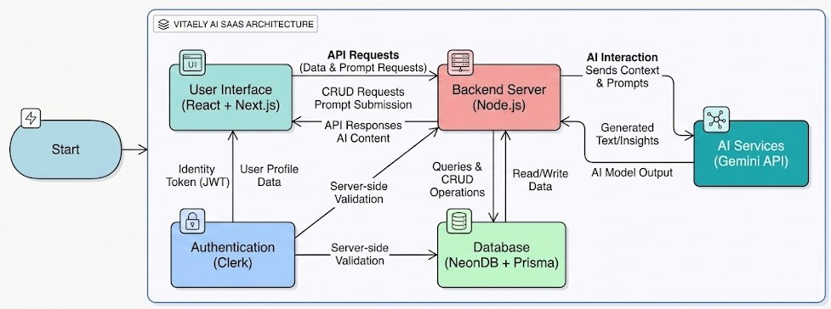

ER DIAGRAM
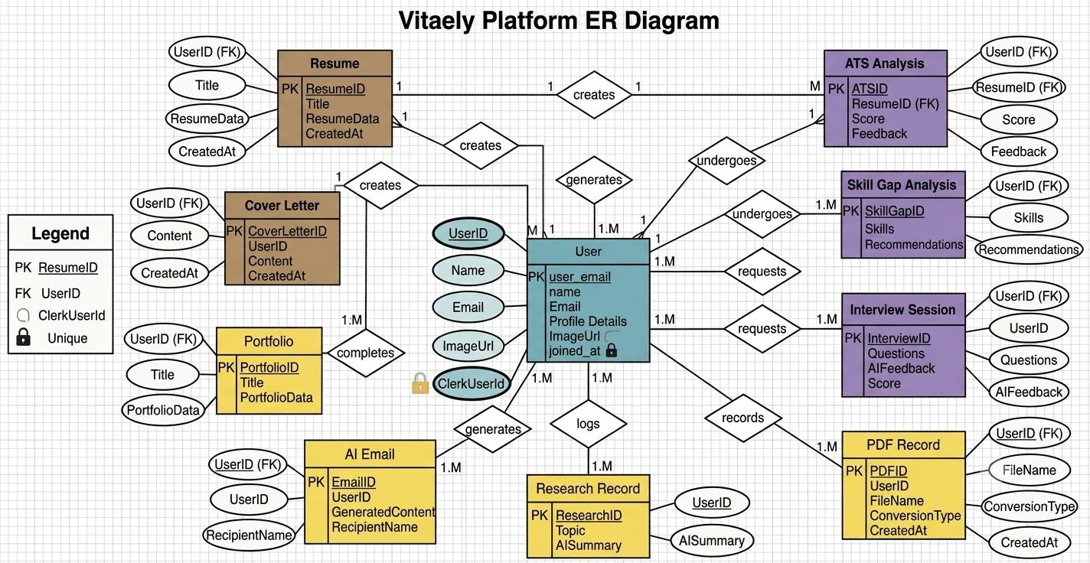

The proposed system, Vitaely, is an AI-powered Software as a Service (SaaS) platform designed to simplify career development through intelligent automation. It integrates multiple career-enhancing tools such as Resume Builder, Cover Letter Generator, Interview Preparation, ATS Score Checker, Skill Gap Analyzer, Industry Insights, Research & Publication Hub, and document management utilities within a single web-based platform.
Vitaely focuses on accessibility, personalization, and efficiency. By leveraging Artificial Intelligence through the Gemini API, the platform provides personalized recommendations, automated content generation, career insights, and interview evaluation based on user profiles and goals.

The system incorporates secure authentication, personalized dashboards, cloud-based data management, and a scalable architecture. As a SaaS application, it can be accessed from any device with an internet connection without requiring local installation.

Overall, Vitaely aims to provide Career Development-as-a-Service, enabling students, job seekers, professionals, and researchers to enhance their skills, improve employability, and make informed career decisions through a unified and user-friendly platform.
.

A feasibility study is conducted to evaluate the practicality and viability of the proposed system from technical, economic, and operational perspectives.

- Technical Feasibility

From a technical perspective, Vitaely is highly feasible due to the availability of modern web development frameworks, cloud databases, and AI technologies. The system is developed using React 19, Next.js 15, Tailwind CSS, NeonDB, Prisma ORM, Clerk Authentication, and Gemini AI API, which provide a secure, scalable, and efficient foundation for the application.

The integration of AI services through the Gemini API enables intelligent career guidance, resume analysis, interview preparation, and content generation without requiring complex AI model development. These technologies are widely adopted and supported, making the project technically reliable and achievable.

- Economic Feasibility

The economic feasibility of Vitaely is supported by the use of open-source technologies and cloud-based infrastructure, which help reduce development and maintenance costs. The platform is designed to provide multiple career development services through a single application, eliminating the need for users to subscribe to multiple tools.

The expected benefits include improved employability, enhanced productivity, better career planning, and reduced time spent on professional development activities. These advantages make the project economically viable and beneficial for students, job seekers, and professionals.

Operational feasibility evaluates how effectively the system can be used and managed in real-world environments. Vitaely is designed with a user-friendly interface and simplified workflows, enabling students, job seekers, professionals, and researchers to use the platform with minimal training.

The system provides personalized dashboards, automated AI-powered features, and secure cloud-based access, making career development activities more efficient and convenient. Its scalable architecture, reliable performance, and secure authentication mechanisms ensure smooth operation and a positive user experience. Therefore, the proposed system is operationally feasible and suitable for practical deployment.

Requirement analysis identifies the functional and non-functional requirements necessary for the successful operation of the proposed system.

Functional Requirements

The system must allow users to register, log in, and manage their profiles securely. It should provide AI-powered features such as Resume Builder, Cover Letter Generator, Interview Preparation, ATS Score Checker, Skill Gap Analyzer, Industry Insights, Portfolio Website Generator, AI Email Writer, and Research & Publication Hub. Users should be able to access and manage their generated content through a personalized dashboard. The system must efficiently handle AI requests, authentication, and database operations.

Non-Functional Requirements

The system should provide high performance and fast response times for AI-generated outputs. Security must be ensured through secure authentication and data protection mechanisms. The platform should be scalable to support multiple users simultaneously and maintain high availability. The user interface should be responsive, user-friendly, and compatible across different devices and web browsers.

The Use Case Diagram illustrates the interaction between users and the Vitaely system. It shows how users access features such as authentication, resume building, interview preparation, ATS analysis, and other AI-powered career development services.

The diagram provides a clear overview of system functionality and user interactions within the platform.
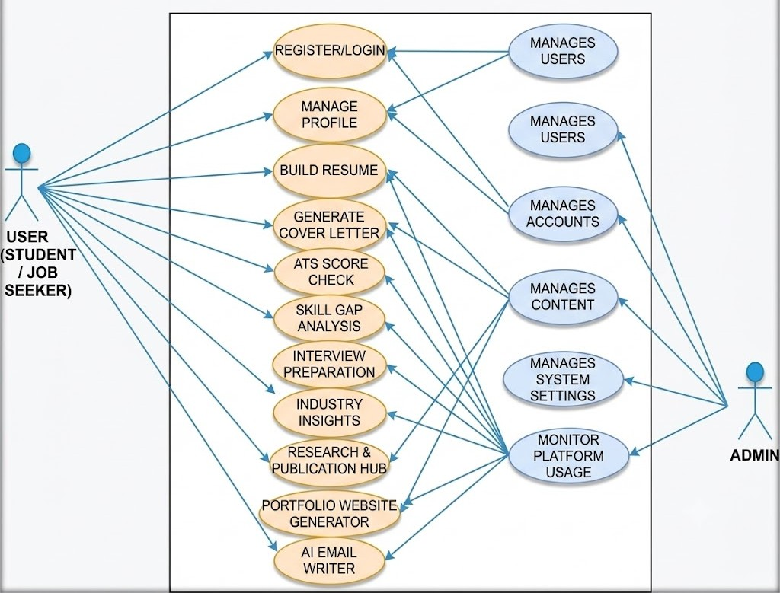

The Data Flow Diagram (DFD) represents the flow of data within the Vitaely system. The Level 0 DFD provides an overview of interactions between users, AI services, and the database. Level 1 and Level 2 DFDs further illustrate processes such as authentication, resume generation, interview preparation, ATS analysis, and data management.

DFDs help in understanding how data is processed, stored, and retrieved within the system, supporting effective system analysis and design.

DFD Level 0 Diagram

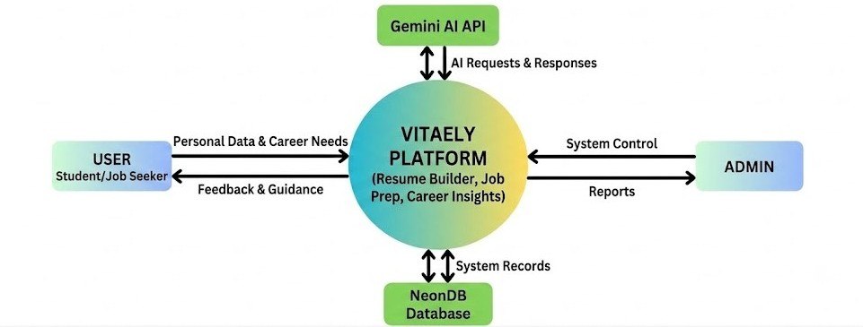

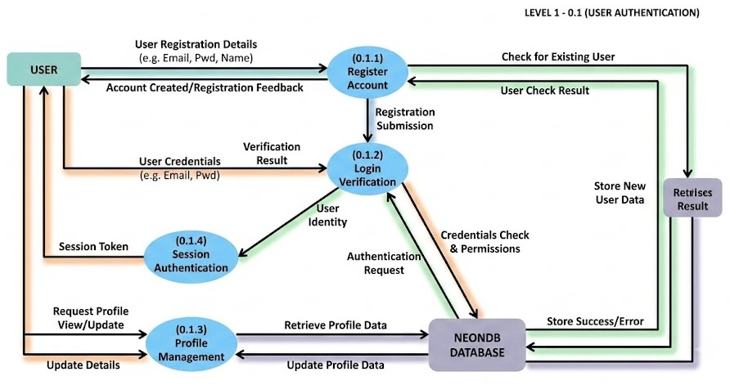

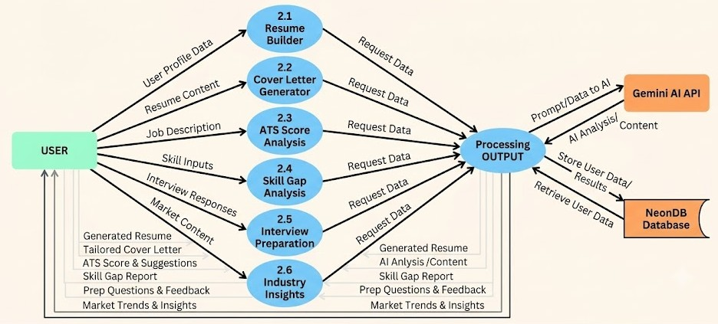

This chapter presented an analysis of existing career development platforms and identified their limitations. It introduced Vitaely as an AI-powered SaaS solution designed to provide integrated career development services through automation and intelligent recommendations. The feasibility study confirmed the technical, economic, and operational viability of the project, while the requirement analysis defined the key functional and non-functional requirements. The chapter also discussed the Use Case and Data Flow Diagrams, providing a foundation for the system design presented in the next chapter.

Introduction to System Design

System design is a crucial phase of the Software Development Life Cycle (SDLC) that transforms system requirements into a structured technical solution. While system analysis focuses on identifying what the system should do, system design defines how those requirements will be implemented through architecture, databases, modules, and user interfaces.

For an AI-powered SaaS platform like Vitaely, system design is essential for ensuring scalability, security, performance, and maintainability. The design incorporates modern web technologies, AI services, cloud-based infrastructure, and secure authentication mechanisms to deliver an efficient user experience.

This chapter presents the design of the Vitaely platform, including system architecture, module design, database structure, user interface design, and security considerations. The proposed design aims to provide a flexible, scalable, and user-friendly career development solution.
.

The design of Vitaely is based on key principles such as modularity, scalability, security, and usability. Modularity allows different system components to be developed and maintained independently, making the platform easier to manage and extend.

Scalability ensures that the system can support a growing number of users and AI requests without affecting performance. Security is maintained through secure authentication, authorization, and data protection mechanisms. Additionally, the platform is designed to be responsive and user-friendly, providing a seamless experience across different devices and browsers.

Vitaely follows a layered SaaS architecture that separates responsibilities across different system components, improving scalability, security, and maintainability. The architecture follows a client-server model where the frontend, backend, database, and AI services communicate through well-defined interfaces.

The presentation layer consists of a web-based frontend developed using React 19, Next.js 15, and Tailwind CSS. This layer manages user interactions, navigation, and data presentation through a responsive and user-friendly interface.

The application layer handles business logic, authentication, AI processing, and request management. It integrates Clerk Authentication for secure user access and coordinates communication between the frontend, database, and AI services.

The data layer utilizes NeonDB and Prisma ORM to store and manage user profiles, resumes, interview records, ATS reports, generated content, and application data securely and efficiently.

The AI services layer integrates the Gemini API to provide intelligent features such as resume generation, cover letter creation, interview preparation, skill gap analysis, industry insights, research assistance, and other AI-powered career development services.

This layered architecture ensures flexibility, scalability, and efficient system performance while supporting future enhancements.

The architectural diagram illustrates the interaction between the major components of the Vitaely platform. Users access the system through a web browser, where the React and Next.js-based frontend provides an interactive user interface. User requests are sent to the application layer, which handles authentication, business logic, and communication with the database and AI services.

The system uses Clerk Authentication for secure access, NeonDB with Prisma ORM for data management, and the Gemini API for AI-powered functionalities. The processed results are returned to the frontend and displayed to the user through a personalized dashboard.

This architecture ensures efficient communication, secure data handling, scalability, and a seamless user experience while supporting future enhancements.

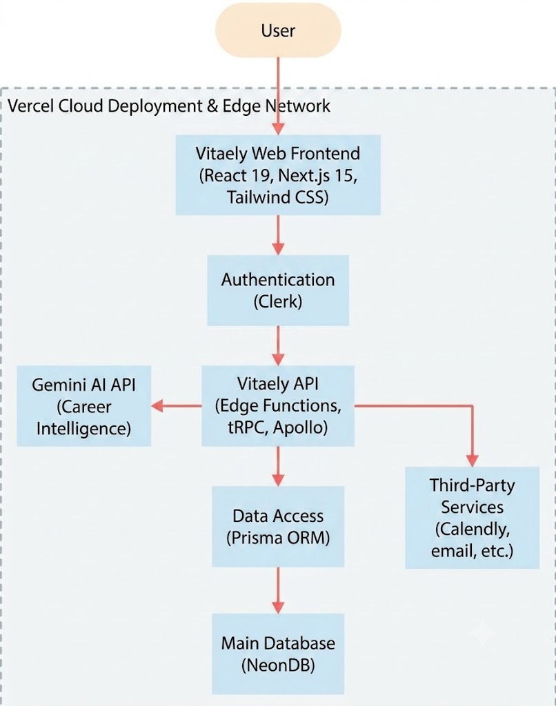

The modular design of Vitaely ensures that each component performs a specific function, improving maintainability, scalability, and development efficiency.

User Authentication and Authorization Module

This module manages user registration, login, profile management, and secure access control. It utilizes Clerk Authentication to ensure secure user identity management and protect sensitive user data.

Resume and Cover Letter Generation Module

This module enables users to create professional resumes and cover letters using AI assistance. It supports multiple templates and generates personalized content based on user information and career goals.

Interview Preparation and Career Analysis Module

This module provides AI-powered interview preparation, ATS score analysis, skill gap assessment, and industry insights. It helps users evaluate their readiness for job opportunities and identify areas for improvement.

Research and Productivity Tools Module

This module includes features such as Research & Publication Hub, Portfolio Website Generator, AI Email Writer, PDF-to-Word Conversion, Word-to-PDF Conversion, PDF Compressor, and AI Project Idea Generator. These tools enhance productivity and support users in academic and professional activities.

The Dashboard Module serves as the central interface of Vitaely, allowing users to access and manage resumes, cover letters, interview reports, ATS scores, skill assessments, research activities, and other generated content.

It provides a personalized and organized workspace that improves user productivity and overall experience.

Administrative and Monitoring Module

This module supports administrative functions such as user management, system monitoring, and performance tracking. It helps administrators oversee platform activities, monitor system health, and ensure the smooth and reliable operation of the application.

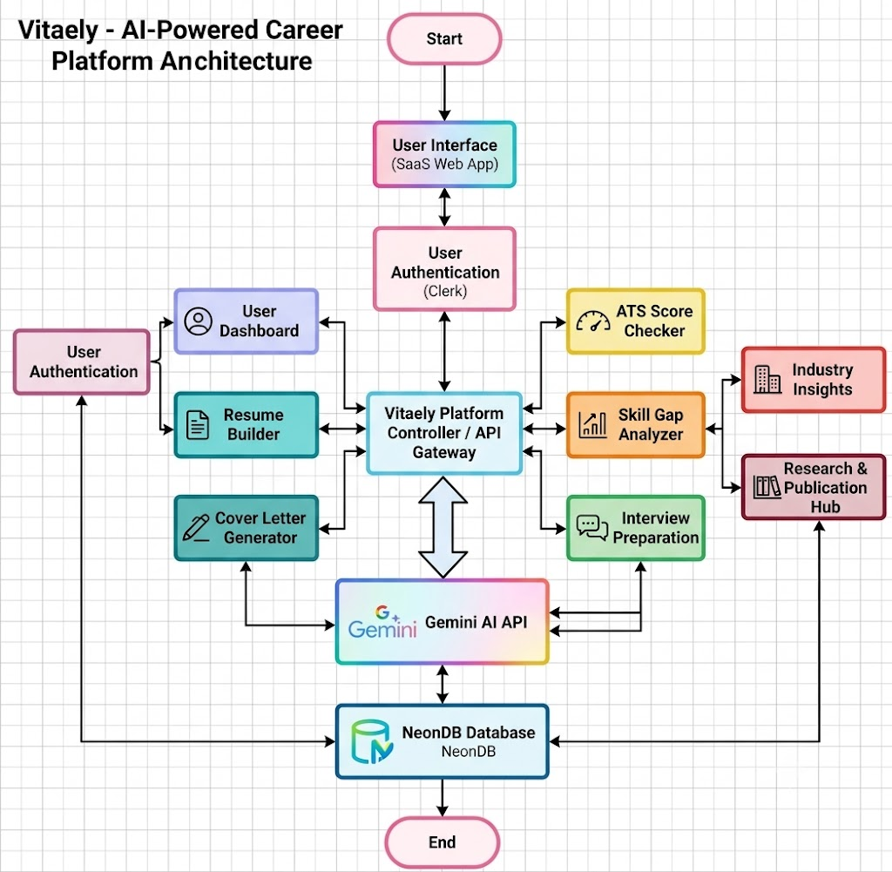

Vitaely uses a RESTful API architecture to enable communication between the frontend, backend, database, and AI services.

The APIs handle operations such as authentication, resume generation, interview analysis, ATS scoring, and content management. Standard HTTP methods, validation mechanisms, and error handling are used to ensure reliability and security.

DATABASE DESIGN

The database is designed using NeonDB and managed through Prisma ORM to support efficient data storage and retrieval. It stores user profiles, resumes, cover letters, interview records,

ATS reports, research data, and generated content. Proper indexing and relational structures ensure scalability and fast query performance.

FRONTEND DESIGN AND USER INTERFACE

The frontend of Vitaely is developed using React 19, Next.js 15, and Tailwind CSS.

The interface is responsive, user-friendly, and designed to provide seamless navigation across different modules. Reusable components and modern UI practices improve usability and user experience.

SECURITY DESIGN AND DATA PROTECTION

Security is incorporated throughout the system using Clerk Authentication, secure session management, and protected API access. User data is safeguarded through authentication, authorization, input validation, and secure communication protocols, ensuring confidentiality and integrity.

SCALABILITY, RELIABILITY, AND PERFORMANCE DESIGN

The system is designed to support scalability through cloud-based deployment and modular architecture. Efficient database operations, optimized API communication, and AI service integration ensure high performance and reliability.

These features enable the platform to support increasing user demands while maintaining a smooth user experience.

SUMMARY OF SYSTEM DESIGN

This chapter presented the system design of Vitaely, including architecture, module design, API communication, database structure, user interface design, security measures, and performance considerations.

The modular and scalable design provides a strong foundation for implementing an efficient AI-powered career development platform.

Introduction to Implementation

System implementation is the phase in which the designed system is transformed into a functional software application. After completing system analysis and design, this phase focuses on developing modules, integrating components, and ensuring that the system operates according to the specified requirements.

The implementation of Vitaely follows a modular and incremental development approach, where individual features are developed and integrated to create a complete AI-powered career development platform. The system is built using modern technologies including React 19, Next.js 15, Tailwind CSS, NeonDB, Prisma ORM, Clerk Authentication, and the Gemini API.

Special emphasis is placed on scalability, security, performance, and user experience to ensure that the platform effectively supports career development activities such as resume building, interview preparation, ATS analysis, skill assessment, and AI-powered career guidance.

System implementation is the phase where the system design is converted into a working software application. It involves developing system modules, integrating components, and ensuring that all functionalities operate as intended.

The implementation of Vitaely follows a modular approach and utilizes technologies such as React 19, Next.js 15, Tailwind CSS, NeonDB, Prisma ORM, Clerk Authentication, and the Gemini API. These technologies help build a secure, scalable, and efficient AI-powered career development platform.
This phase focuses on implementing features such as resume building, interview preparation, ATS analysis, skill assessment, and career guidance while ensuring a smooth and user-friendly experience.

The backend implementation of Vitaely serves as the core of the system, responsible for handling user requests, managing business logic, processing AI operations, and communicating with the database. The backend follows a modern API-driven architecture to ensure efficient and secure interaction with the frontend.

Server Setup and Configuration

The application is built using Next.js 15 with server-side capabilities and API routes. The backend integrates Prisma ORM for database operations and NeonDB for cloud-based data storage. Environment variables are used to securely manage database credentials, authentication keys, and Gemini API configurations.

The project follows a modular structure, separating API routes, services, database operations, and utility functions to improve maintainability and scalability.

User Authentication Implementation

User authentication is implemented using Clerk Authentication, which provides secure user registration, login, session management, and profile handling. Clerk manages user identities and access control while protecting sensitive user information.

Authentication mechanisms ensure that only authorized users can access protected features such as Resume Builder, Interview Preparation, ATS Analysis, Research Hub, and other AI-powered services. Secure session handling and access control help maintain system security and reliability.

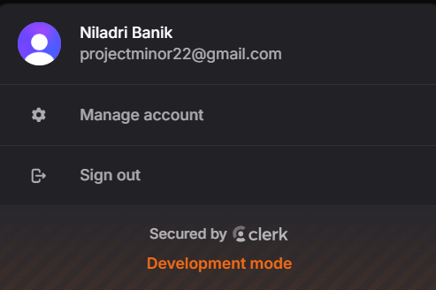
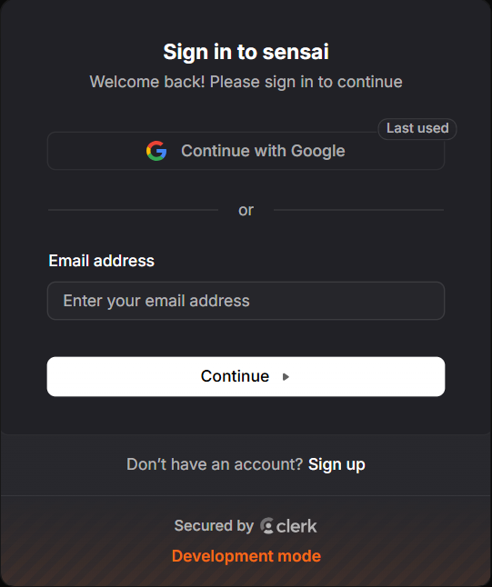
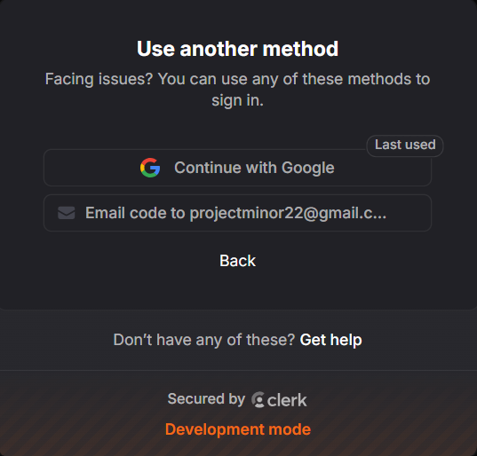
SignIn & SignUp Pages:
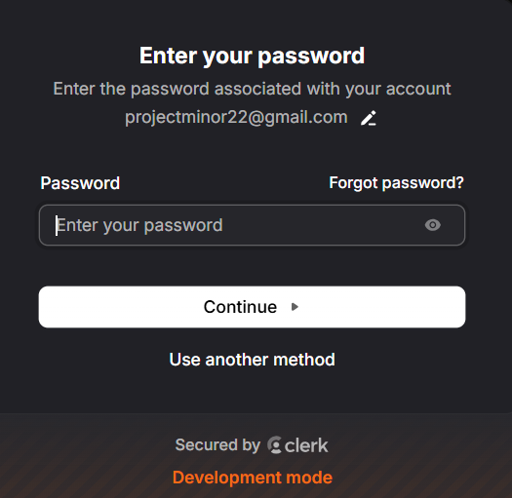

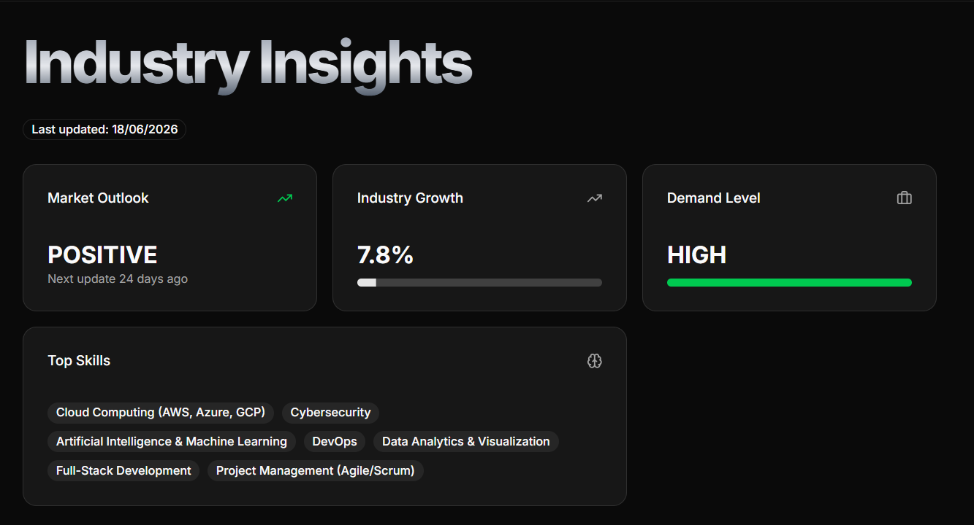

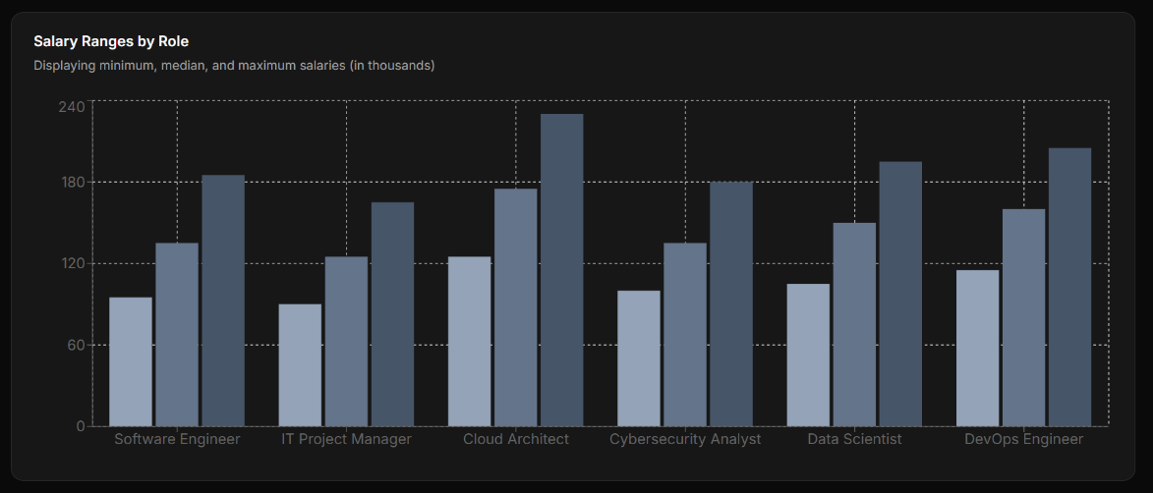

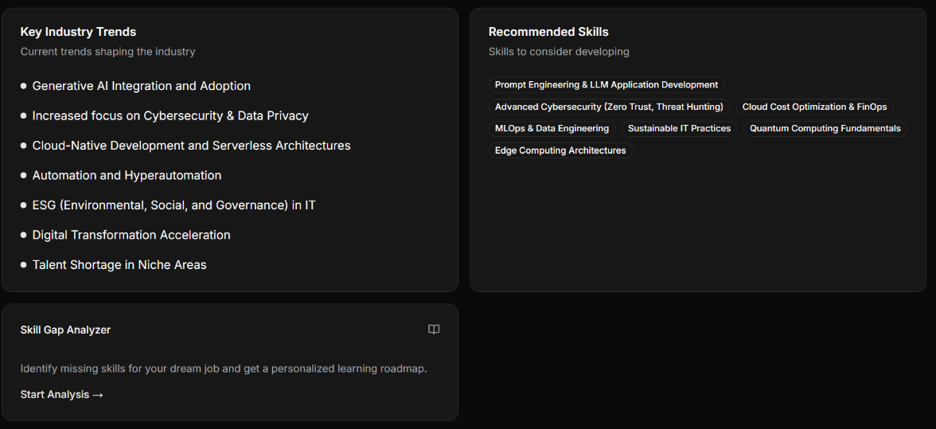

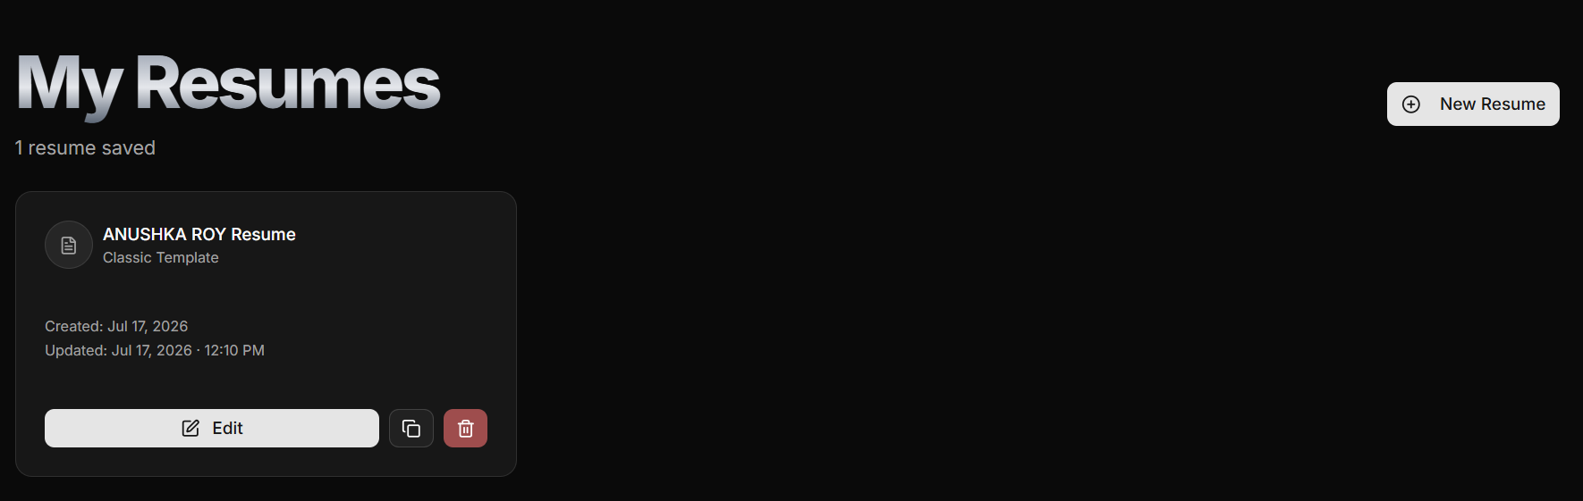

Resume Builder

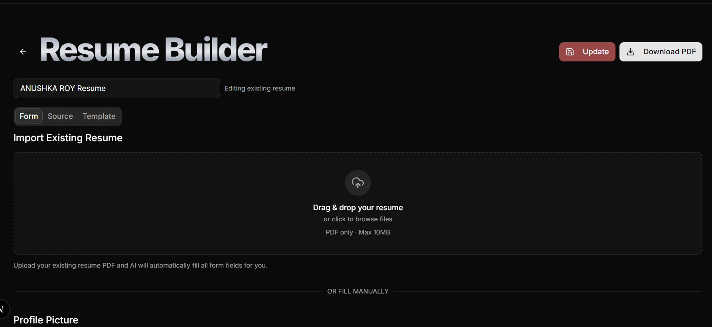
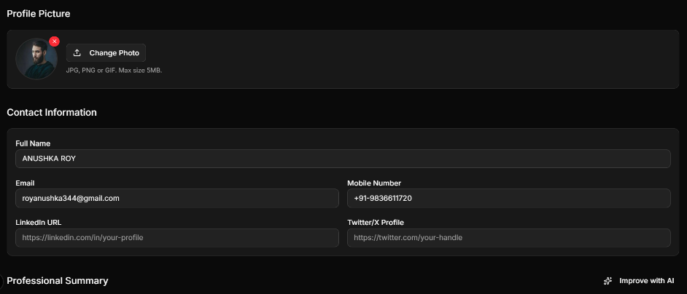

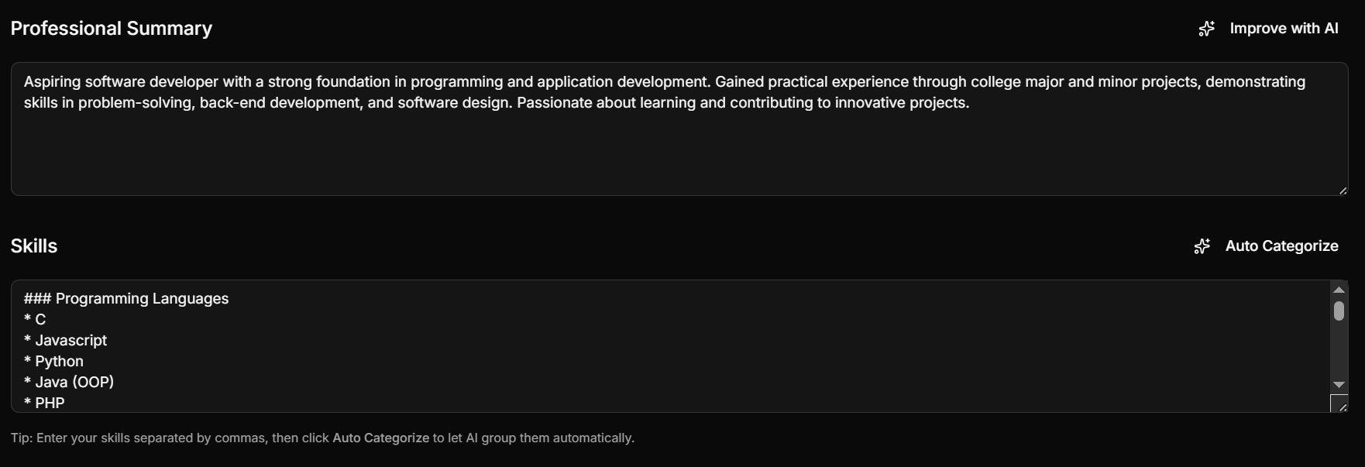

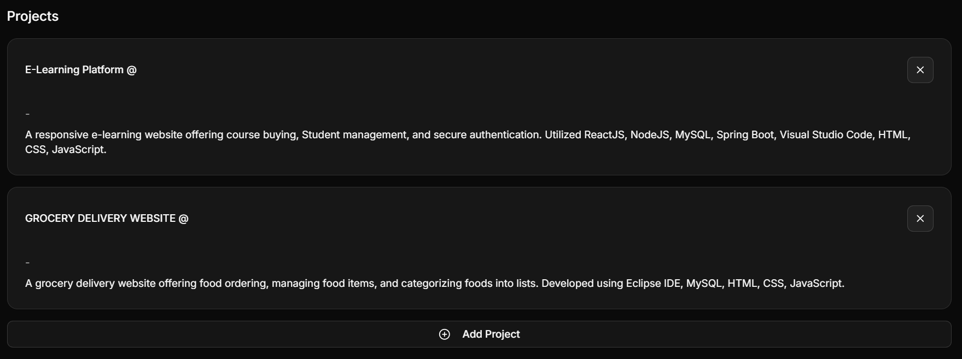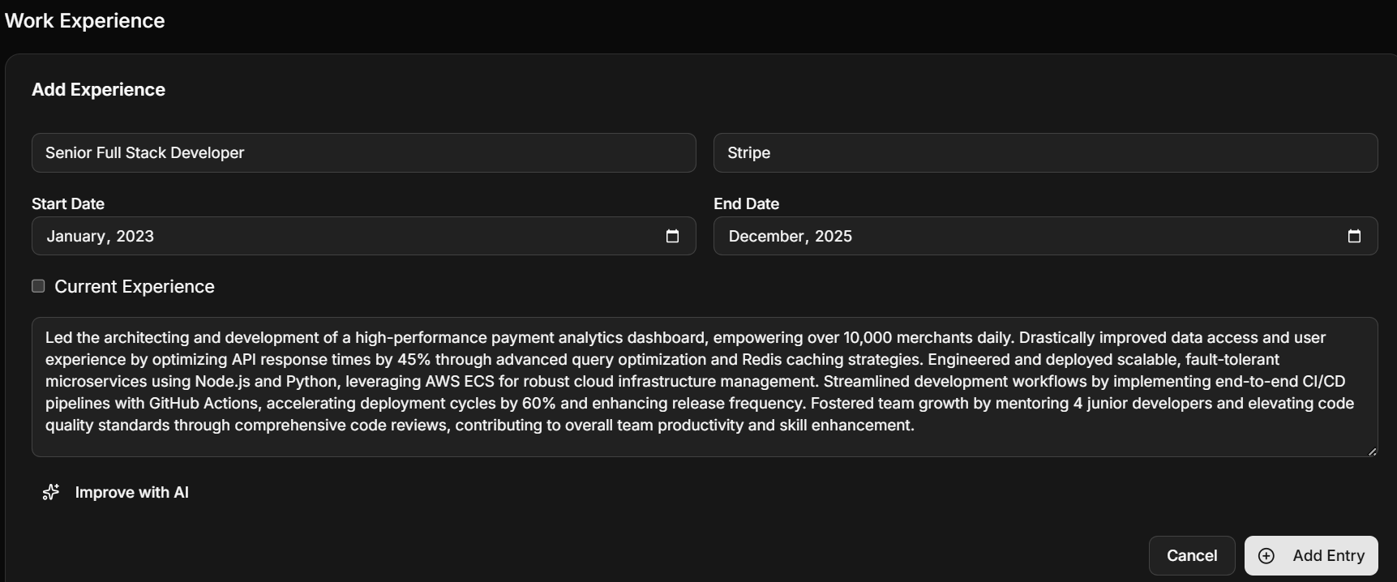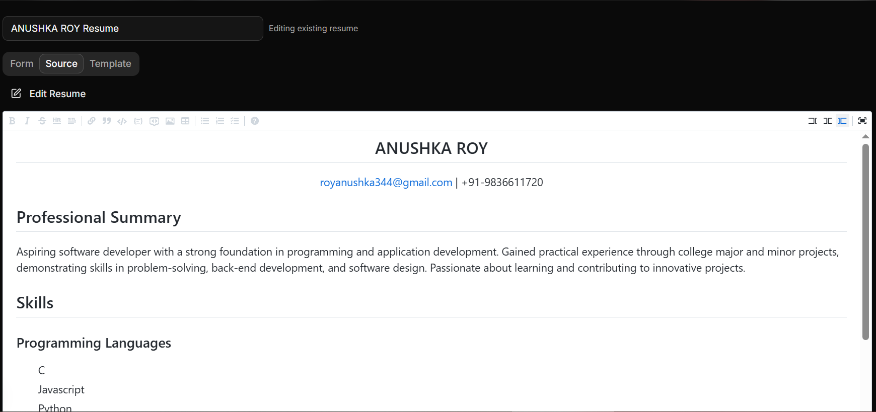
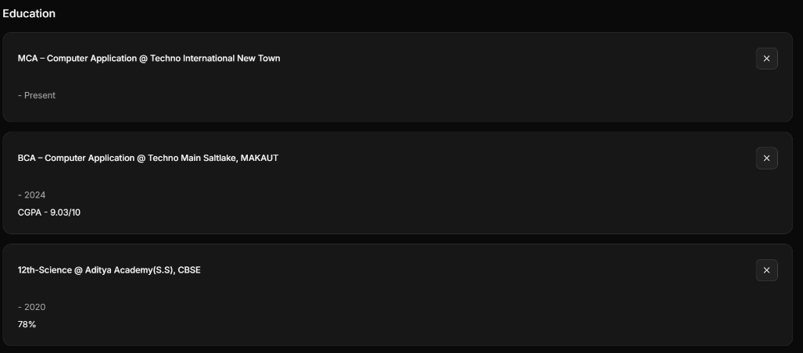
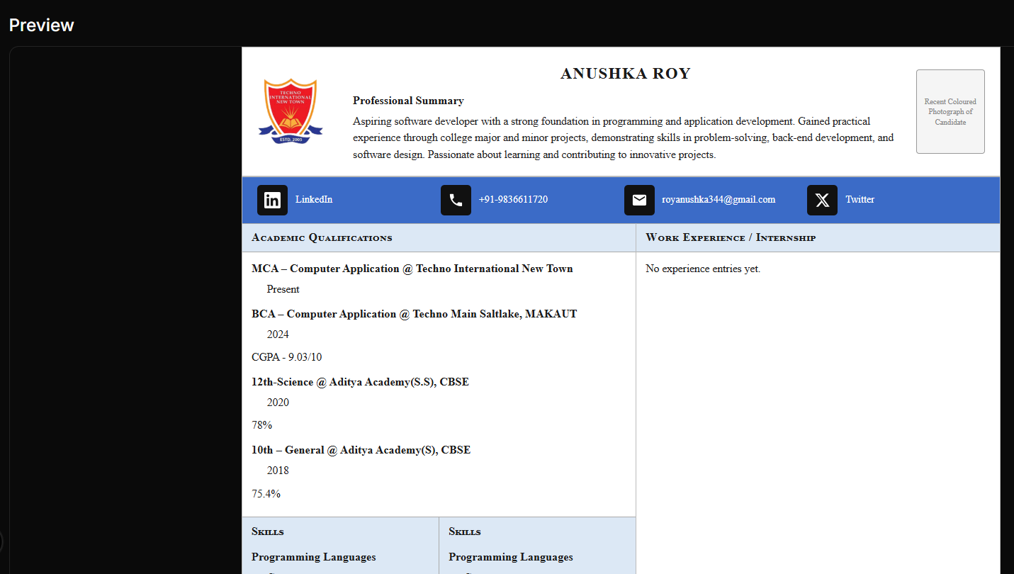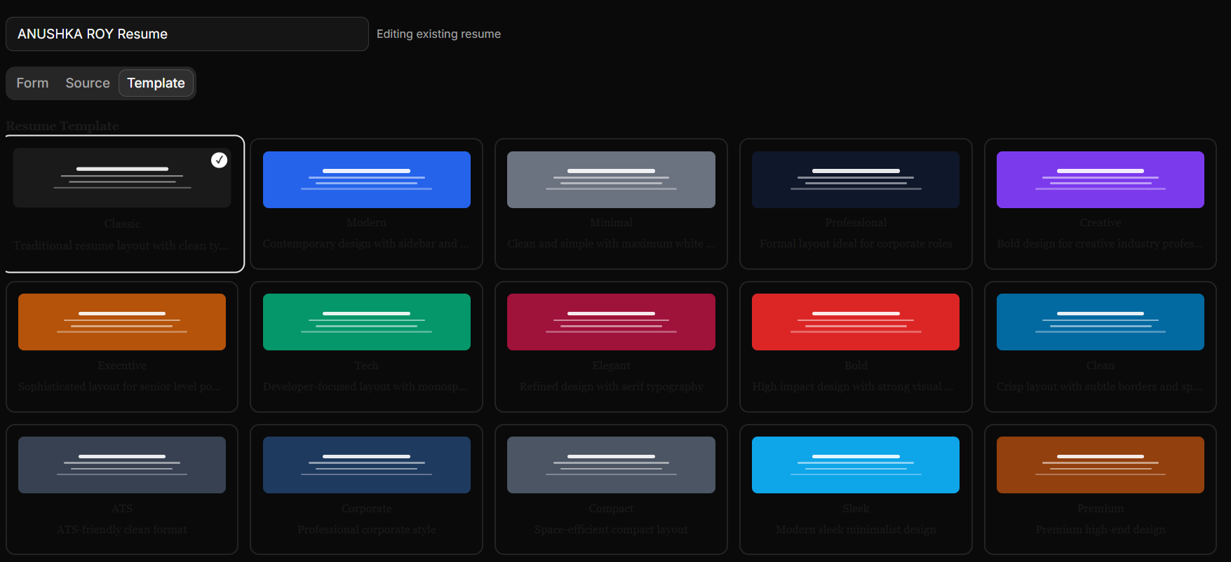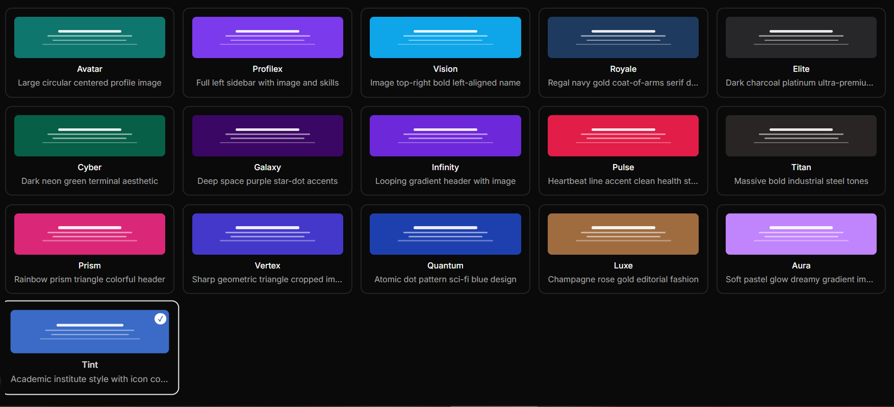
Cover Letters

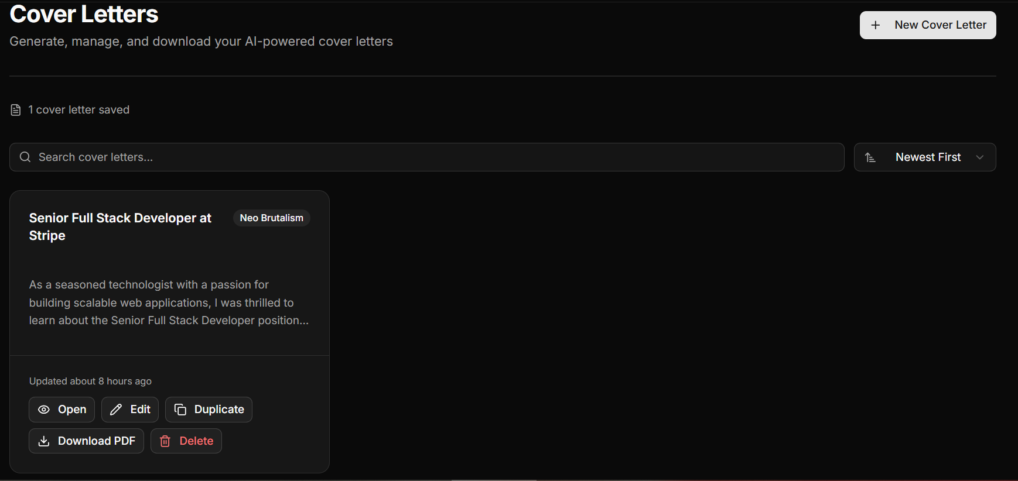

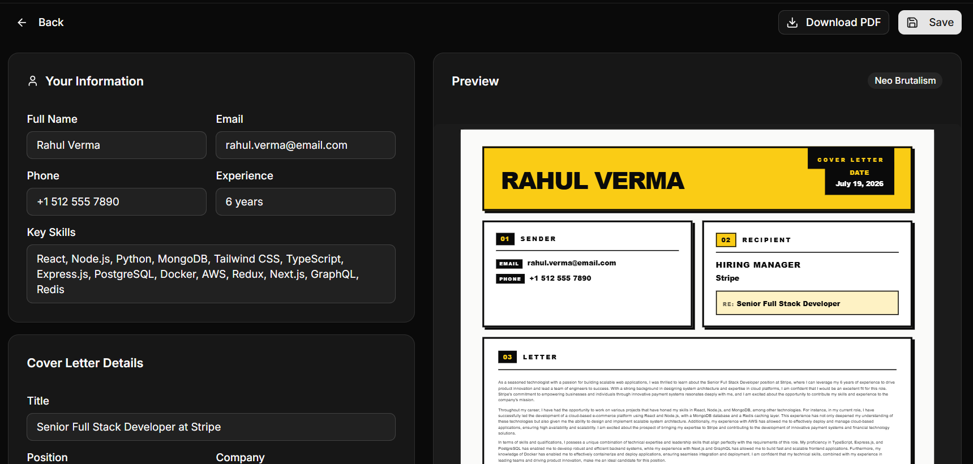
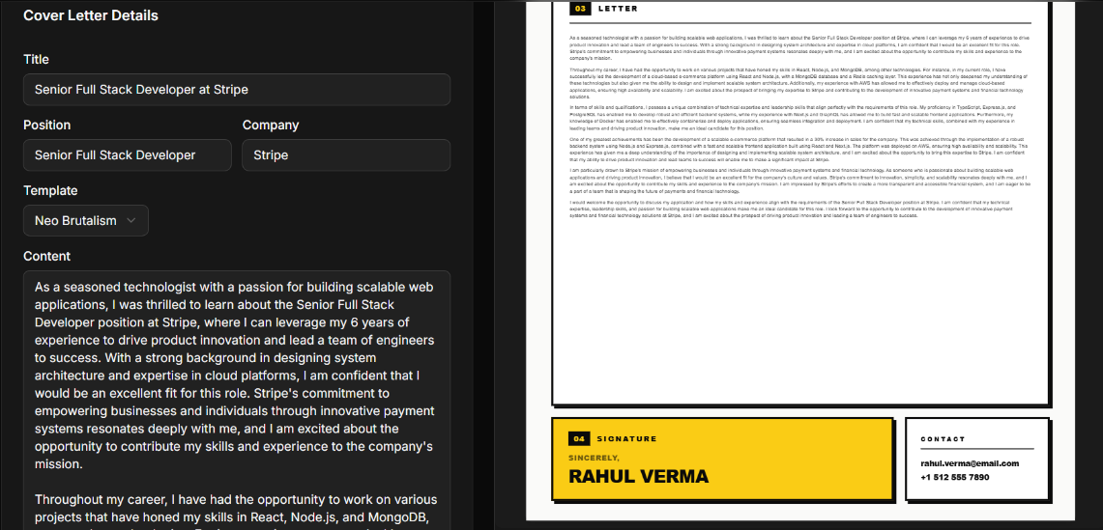

AI Cover Letter Generator

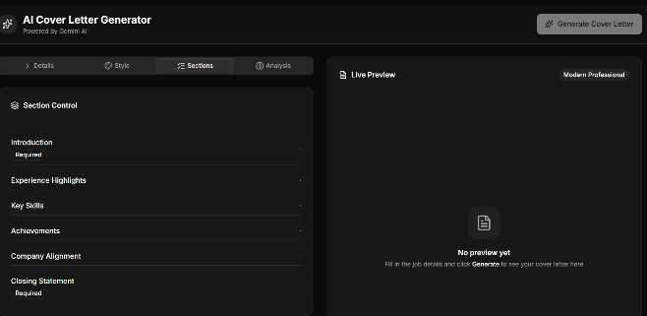
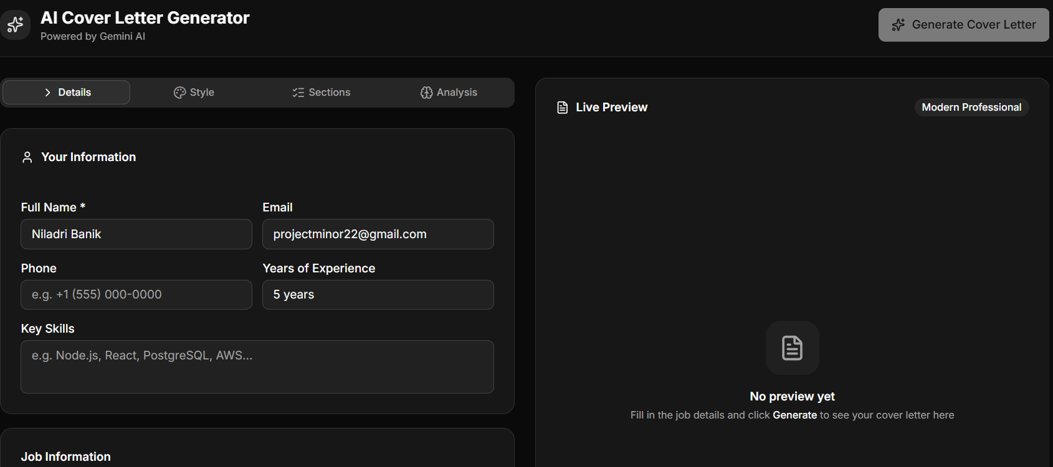

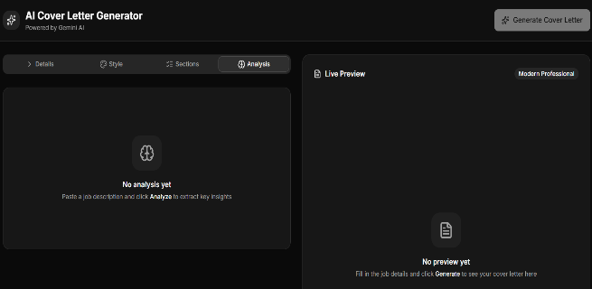
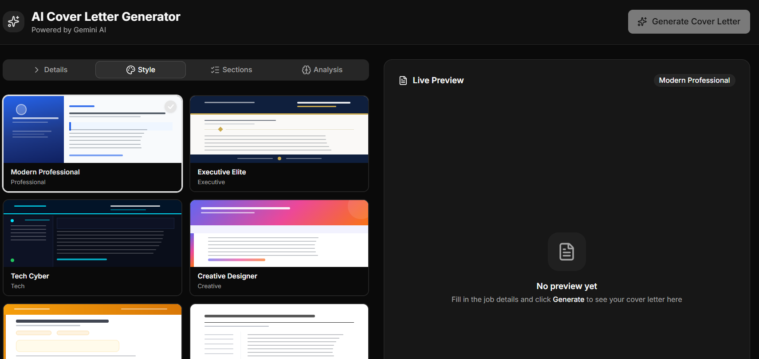
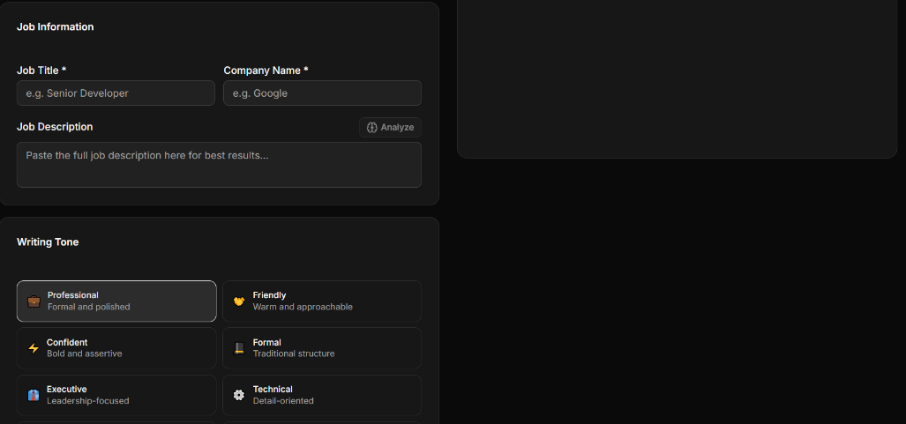

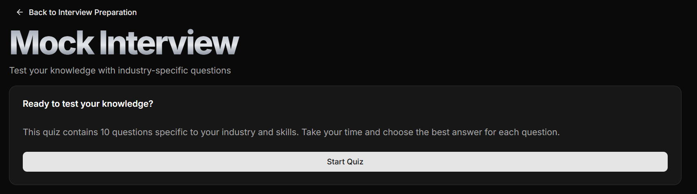
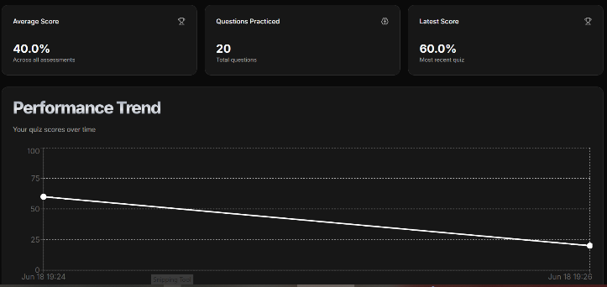
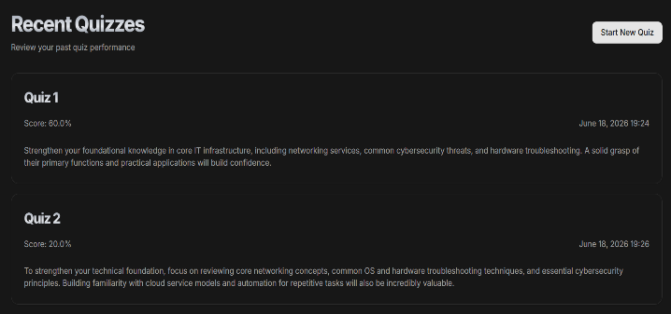
Interview Preparation

PDF to Word Converter
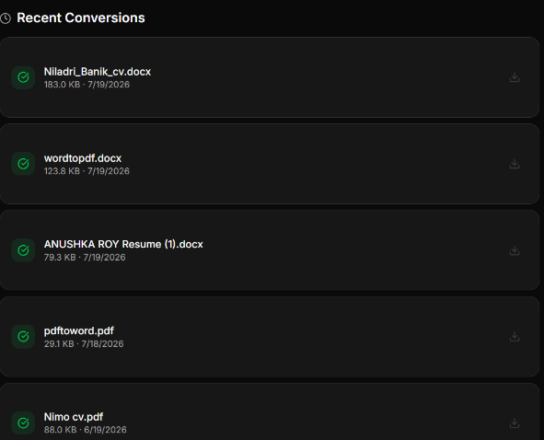
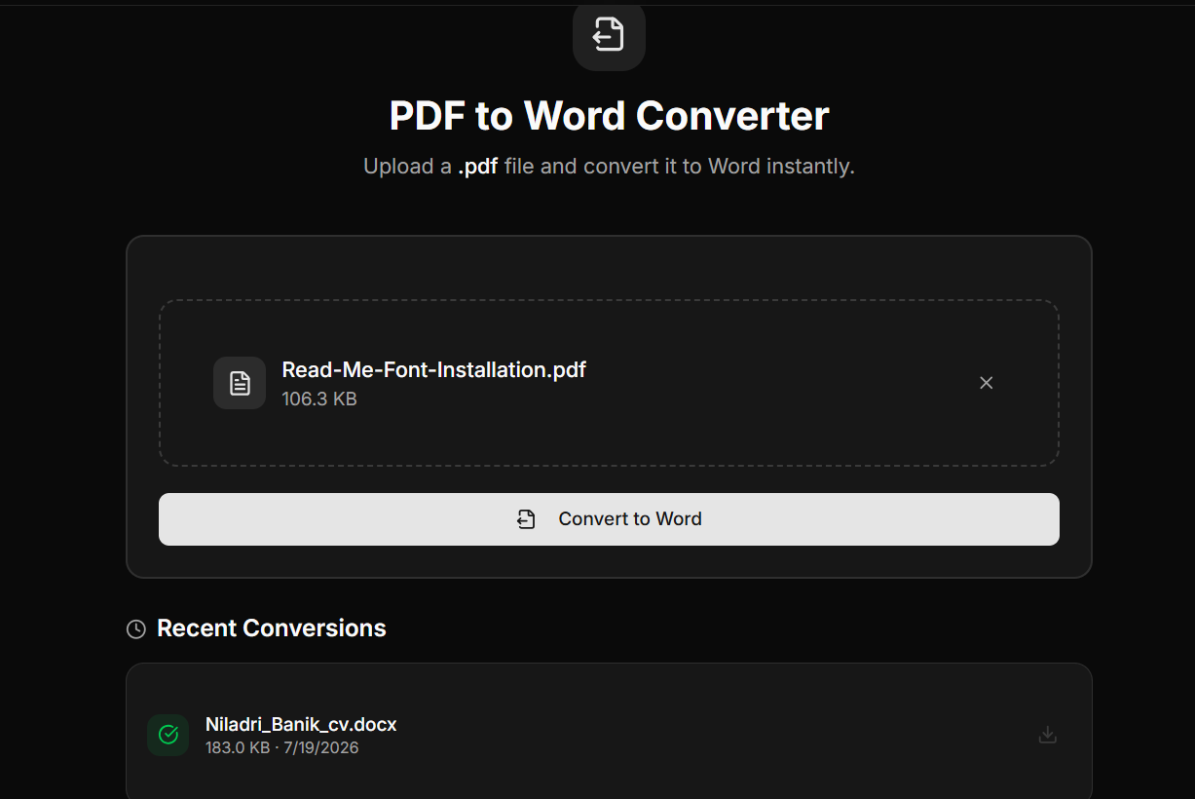

Word to PDF Converter

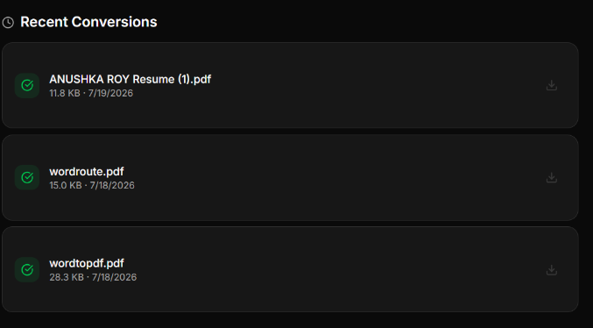
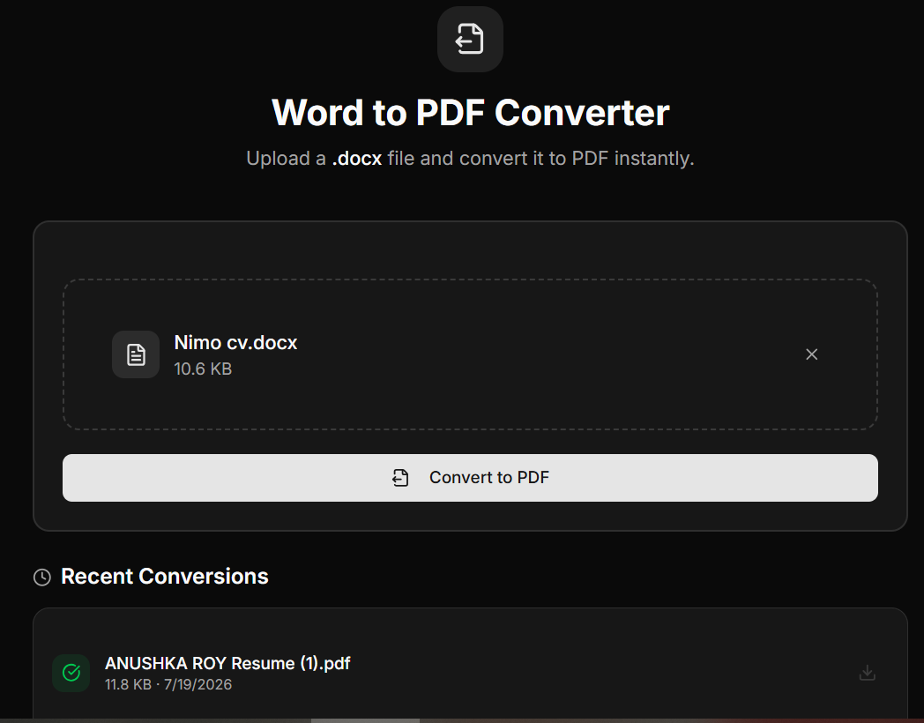

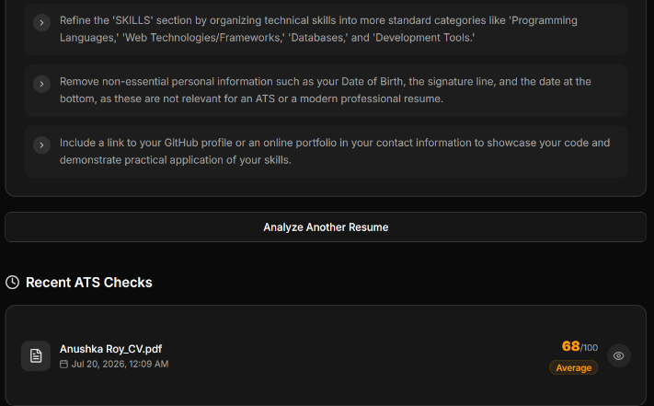
ATS Score Checker
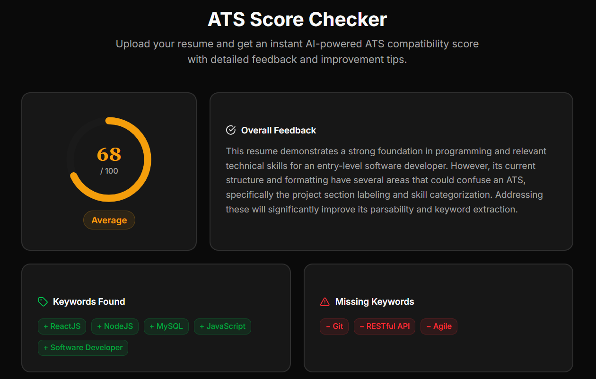

PDF Compressor
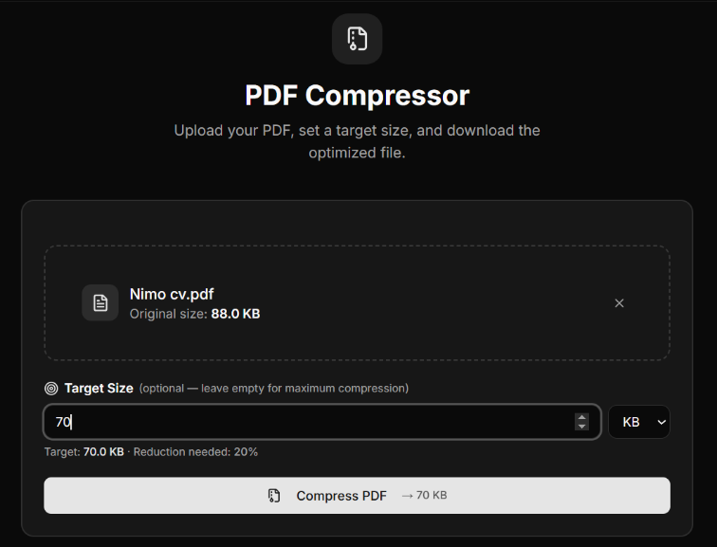

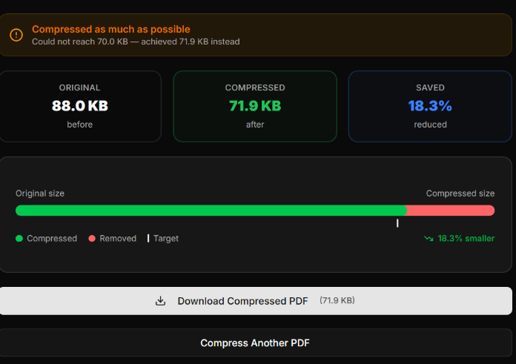

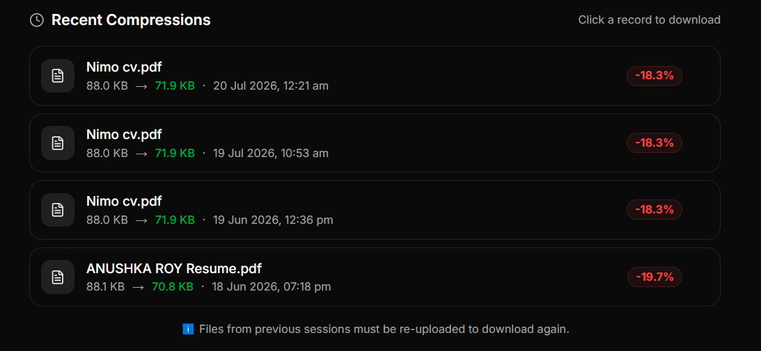

Portfolio Generator
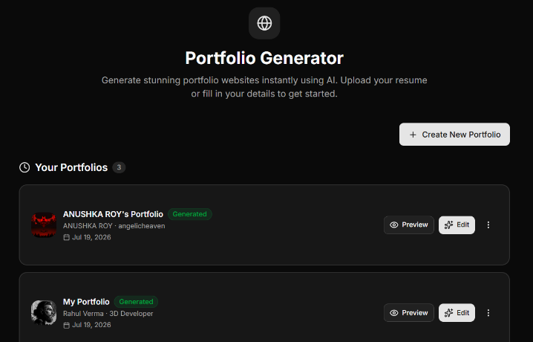
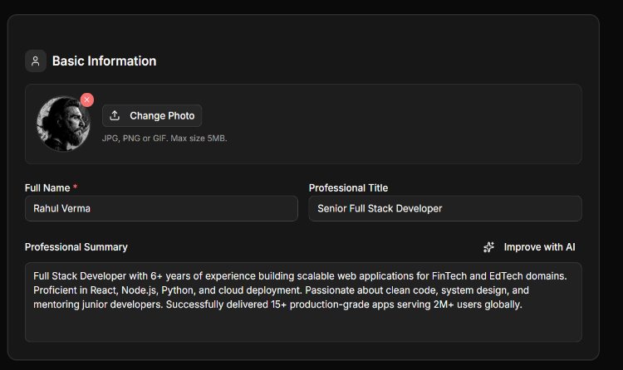
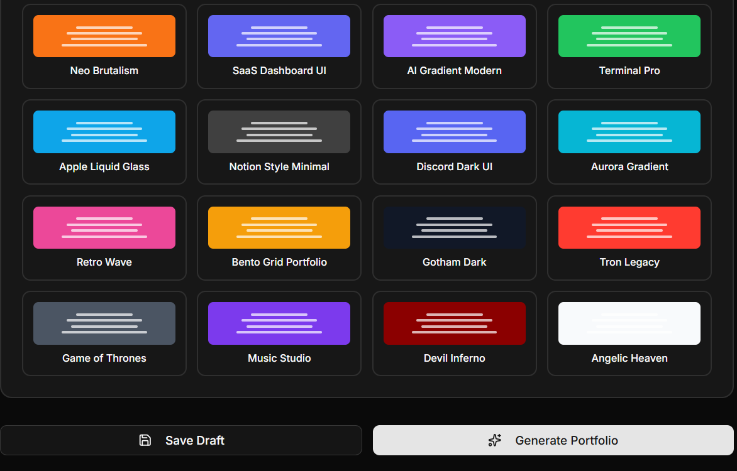
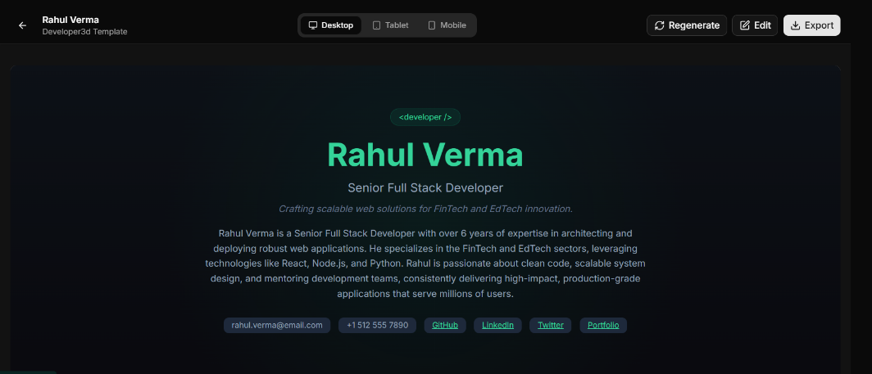

AI Email Writer
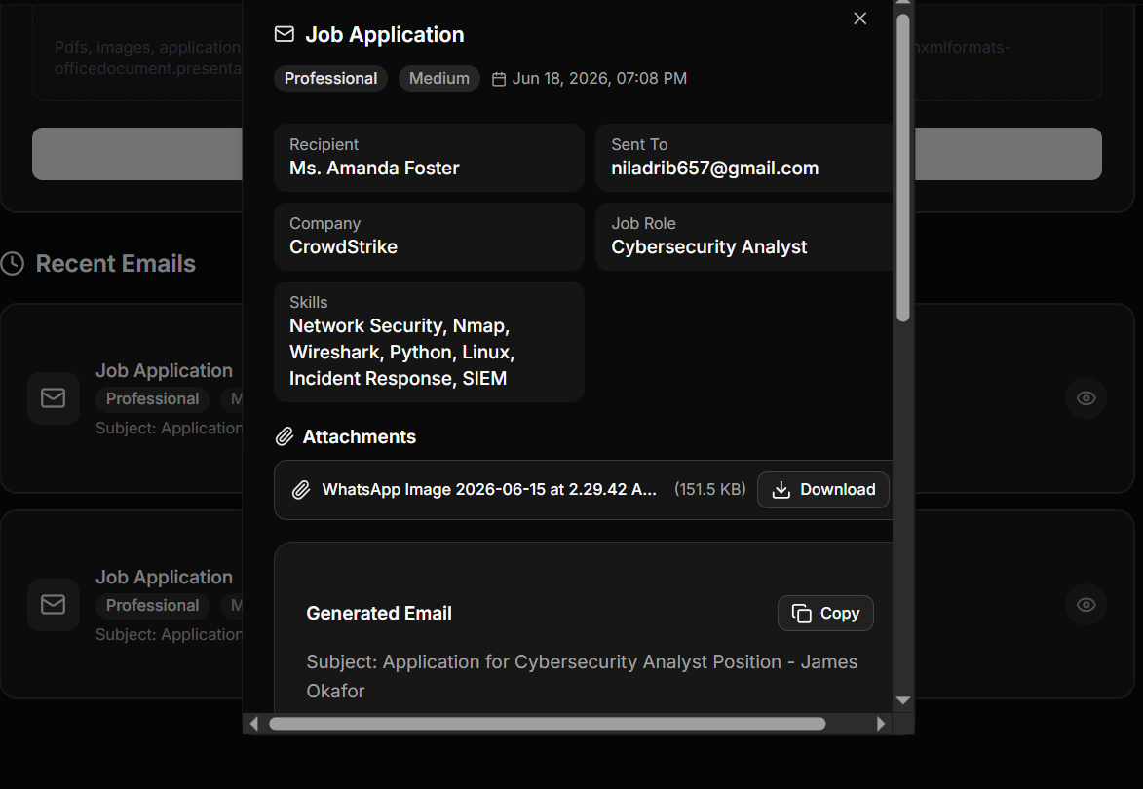
Research Hub
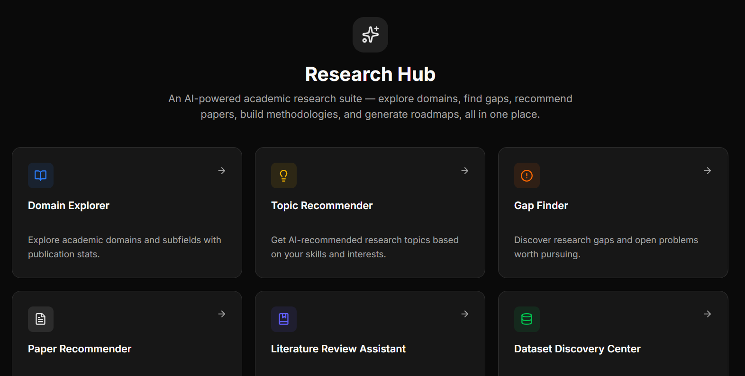
Frontend Implementation
The frontend implementation focuses on delivering an intuitive and responsive user interface that simplifies interaction with AI-powered features. React is used to create reusable UI components and manage application state efficiently.
The dashboard serves as the central interface for users to manage generated content. It displays AI-generated images and titles in an organized manner, along with timestamps and metadata. Users can view their generation history and revisit previous outputs.
The frontend of Vitaely communicates with the backend through RESTful APIs using asynchronous requests. This ensures smooth user experience during operations such as resume generation, interview preparation, and AI-based content creation.
State management is used to efficiently handle user authentication status, profile data, and generated content across different components of the application.

Database Implementation

NeonDB with Prisma ORM is used for database implementation.
The database stores user information, resumes, cover letters, interview records, ATS reports, and other generated content. The schema is designed to ensure scalability, data integrity, and efficient querying.

Indexes and relational structures are used to optimize performance, while access control mechanisms ensure that users can only access their own data securely.

Integration of Modules

After individual modules are developed, they are integrated to form a complete system. The frontend, backend, database, and AI services work together through RESTful APIs.

Integration testing is performed to verify authentication, data flow, and AI response accuracy, ensuring that the system functions as a unified platform.

Deployment Implementation

Vitaely is deployed on cloud-based platforms to ensure scalability, reliability, and high availability. The frontend and backend are hosted separately, while the database is managed using cloud database services.
Version control is maintained using Git and GitHub, enabling collaborative development and proper tracking of changes. Continuous deployment practices ensure smooth updates and system maintenance.

During implementation, several challenges such as API response delays, prompt optimization for AI models, and state management issues were encountered. These challenges were addressed by optimizing API calls, improving modular code structure, and enhancing frontend responsiveness with proper loading indicators and error handling.

SUMMARY OF IMPLEMENTATION

The implementation process provided valuable insights into integrating AI services with full-stack web applications and managing real-time user interactions effectively. It also strengthened understanding of performance optimization, system design, and scalable SaaS architecture.

Introduction to System Testing

System testing is a crucial phase in the Software Development Life Cycle (SDLC) that verifies whether the developed system meets the specified requirements and performs correctly under different conditions. It evaluates the reliability, functionality, performance, and security of the system as a whole.

For an AI-powered SaaS platform like Vitaely, testing is essential due to the integration of multiple components such as frontend interfaces, backend APIs, database operations, and AI-based services. The testing process ensures that all modules work together seamlessly and deliver a smooth user experience.

This chapter outlines the testing objectives, testing strategies, types of testing performed, and the results obtained during the evaluation of the Vitaely platform.

Testing Objectives

The primary objective of system testing in Vitaely is to ensure that all functional requirements are implemented correctly and the system behaves as expected in real-world scenarios.
It also validates non-functional requirements such as performance, security, usability, and scalability.

Testing Strategy

The testing strategy follows a structured approach involving multiple levels of testing, including unit testing, integration testing, system testing, and user acceptance testing. Both positive and negative test cases are considered to ensure robustness and proper error handling.
Testing is conducted throughout the development process to identify defects early, improve system quality, and reduce rework during later stages.

Unit Testing
Unit testing focuses on testing individual modules in isolation. In Vitaely, unit testing is performed on backend functions such as authentication logic, API endpoints, and data processing services. Frontend components are also tested to ensure correct rendering and behavior. This helps verify that each module performs its intended function correctly.

Integration Testing
Integration testing evaluates the interaction between different system components. It ensures proper communication between the frontend and backend, backend and database, and backend and AI services. This phase verifies that data flows correctly across modules and that APIs function as expected.

System Testing
System testing examines the complete integrated system. It validates both functional and non-functional requirements under real-world conditions. Key features such as user registration, login, resume generation, interview preparation, ATS analysis, and dashboard management are tested for correctness and performance.

User Acceptance Testing (UAT)
User Acceptance Testing is conducted to evaluate the system from the end-user’s perspective. Selected users interact with the platform to assess usability, accessibility, and overall experience. Feedback collected during this phase is used to refine the system and ensure it meets user expectations.

Test Case Design
Test cases are designed to ensure complete coverage of system functionality. Each test case includes a unique ID, description, input data, expected output, actual output, and result status. This structured approach improves traceability and ensures systematic validation of all modules.

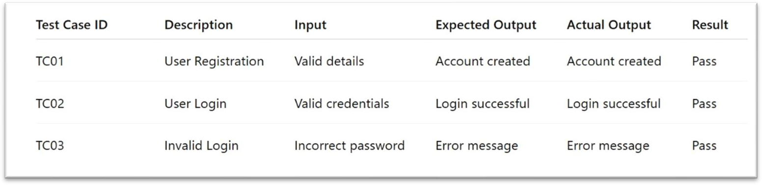

Functional Testing Results
Functional testing confirms that all system features operate according to specifications. The results show that user authentication, AI-based content generation, and dashboard management work correctly. The system successfully processes valid inputs and provides appropriate feedback for invalid inputs.

Performance Testing
Performance testing evaluates the system’s responsiveness and stability under different workloads. In Vitaely, testing focuses on API response times, AI processing latency, and frontend rendering performance under simulated user load conditions.

The results indicate that the system handles concurrent users efficiently and maintains stable response times during peak usage.

Security Testing
Security testing ensures that the system is protected against unauthorized access and vulnerabilities. Authentication and authorization mechanisms are verified to ensure secure access control. Input validation is tested to prevent common security threats such as injection attacks.

The results confirm that user data confidentiality and system integrity are properly maintained through secure authentication mechanisms.

Usability testing evaluates the user experience in terms of interface design, navigation, and accessibility. Users interact with the platform to assess ease of use and responsiveness across different devices.

Feedback indicates that the interface is intuitive, user-friendly, and accessible, ensuring a smooth experience for all users.

Result Analysis
Overall testing results demonstrate that the Vitaely platform meets its functional and non-functional requirements. The system performs reliably, integrates AI services effectively, and provides a stable and efficient user experience. Identified issues during testing were resolved, improving overall system quality and performance.

Successful login and registration

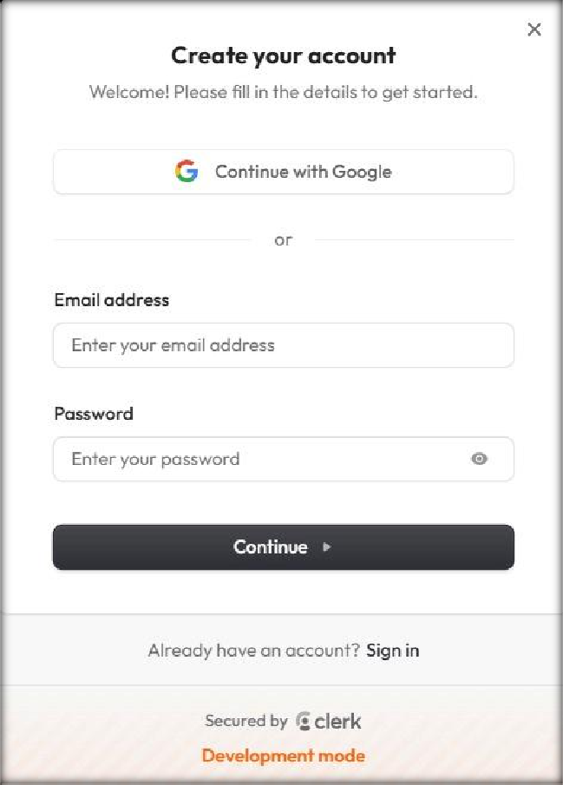
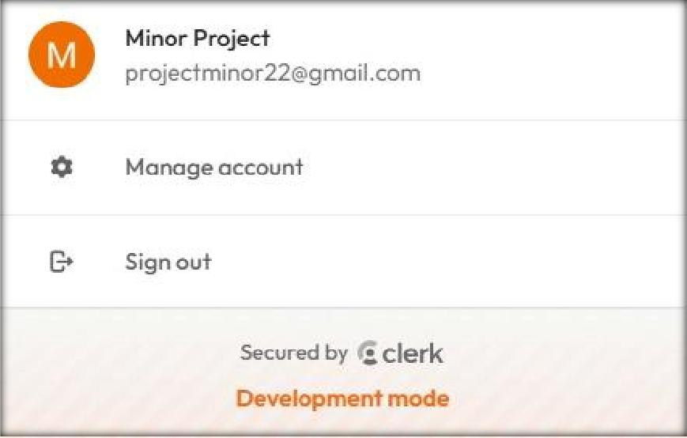

Dashboard
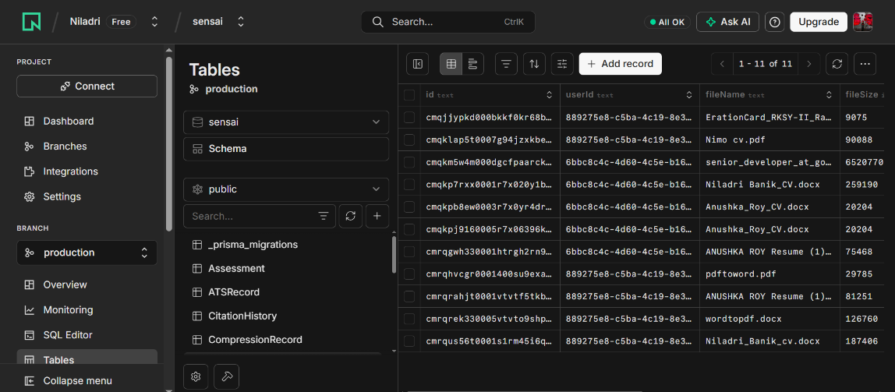

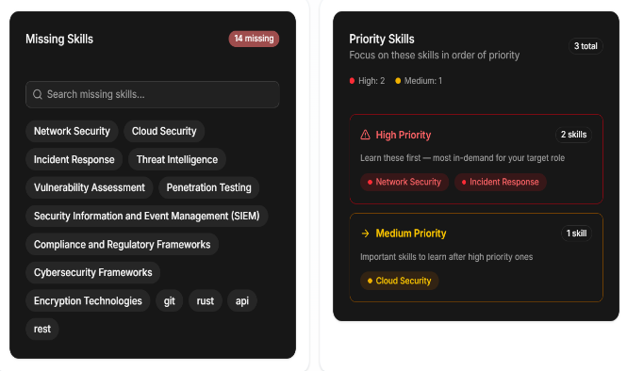
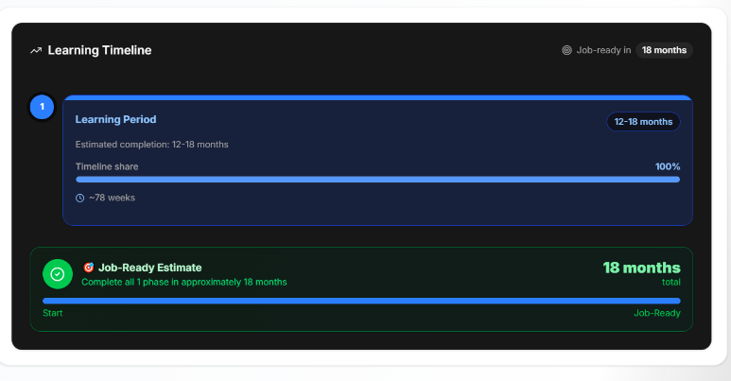

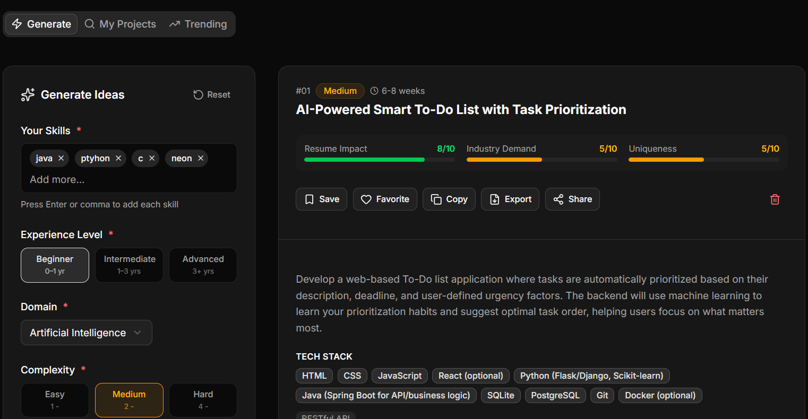
AI Project Idea Generator

Domain Explorer
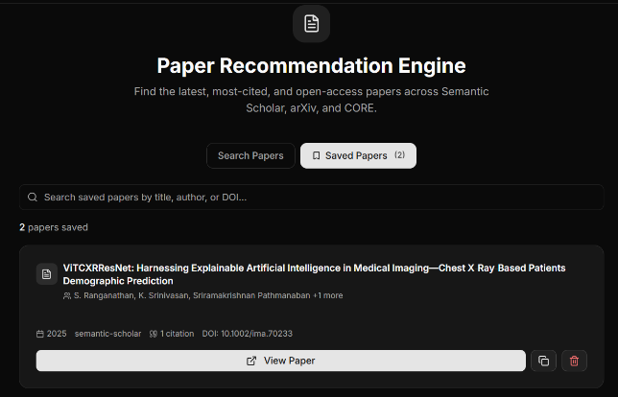
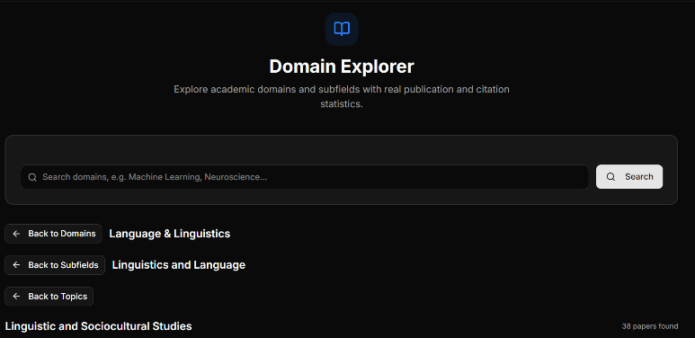
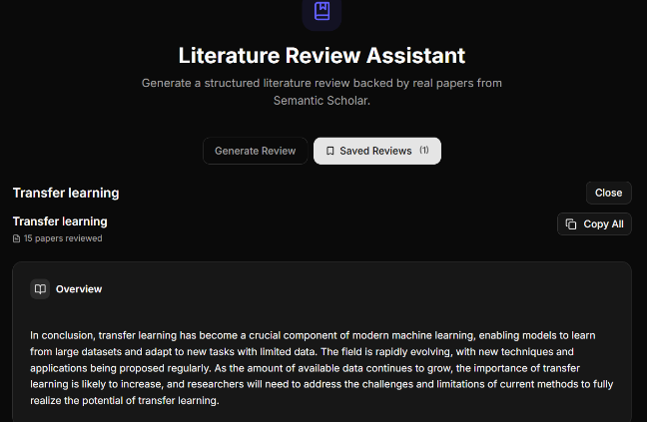
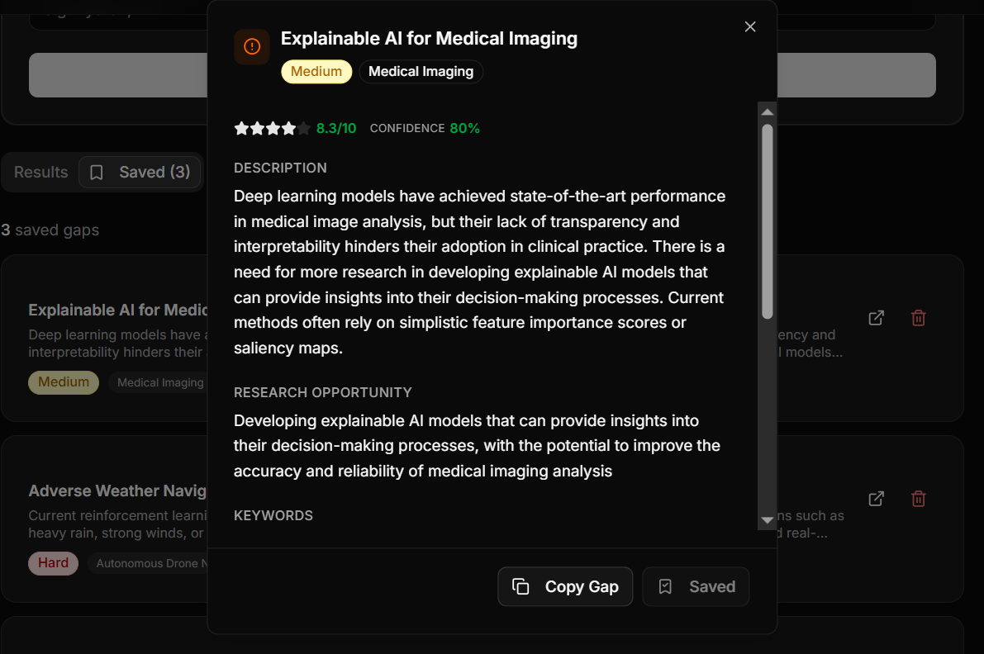

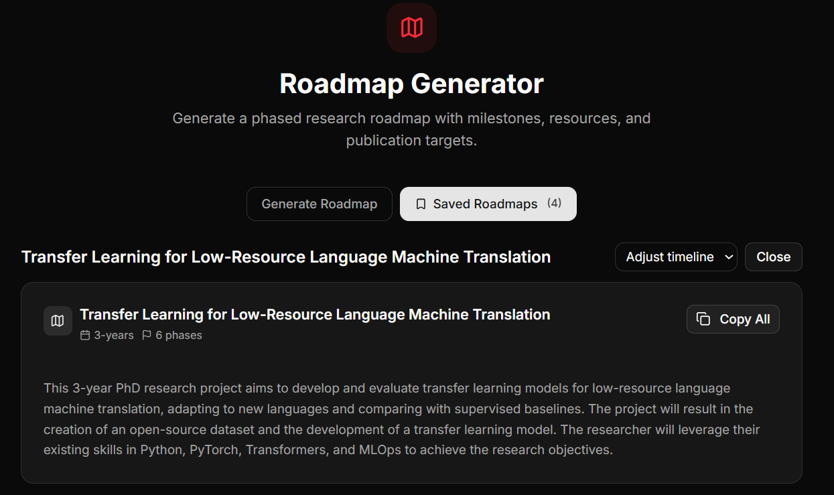

During testing, certain limitations such as AI service latency and dependency on external APIs were identified. These challenges are common in AI-based systems and may affect response times under high load. They were addressed through optimization techniques, efficient request handling, and fallback mechanisms to improve system reliability.

SUMMARY OF TESTING AND RESULTS

This chapter presented the testing methodology adopted for the Vitaely platform, including unit testing, integration testing, system testing, user acceptance testing, and performance evaluation. Test case design and result analysis were also discussed.
The results confirm that the system operates reliably, meets functional and non-functional requirements, and delivers a satisfactory user experience. Overall testing outcomes validate the effectiveness of the proposed AI-powered SaaS solution and support its readiness for deployment and future enhancements.

The conclusion and future scope chapter summarizes the entire Vitaely project, including its objectives, outcomes, and development experience. It reflects on how effectively the system achieves its goal of providing an integrated, AI-powered career development platform.

The project demonstrates the practical application of modern web technologies and artificial intelligence in solving real-world challenges faced by students, job seekers, and professionals. The system successfully integrates multiple career enhancement tools into a single SaaS platform, improving accessibility, efficiency, and user experience.
This chapter also highlights the significance of the project in the context of evolving technological trends such as AI automation, cloud computing, and intelligent SaaS solutions. Overall, Vitaely proves to be an effective and scalable platform for career development support.

The future scope of Vitaely includes several potential enhancements such as advanced AI models for more accurate career predictions, integration of real-time job portals, personalized learning recommendations, and voice-based interaction features.
Additional improvements may include mobile application development, premium subscription models, collaboration tools, and integration with professional networking platforms. These enhancements can further increase the usability, scalability, and impact of the system in the future.

The Vitaely project was developed with the objective of creating a unified, intelligent, and user-friendly SaaS platform that simplifies career development through artificial intelligence. The system integrates multiple AI-powered services such as resume building, cover letter generation, interview preparation, ATS analysis, skill gap assessment, industry insights, research assistance, and productivity tools within a single web-based application.
By leveraging modern full-stack technologies and AI services, Vitaely aims to reduce the complexity, time, and effort involved in traditional career preparation processes. The platform provides an all-in-one solution that enhances accessibility, efficiency, and personalization for users.
The development process followed a structured Software Development Life Cycle (SDLC), including requirement analysis, system design, implementation, and testing. Each phase contributed to building a scalable, secure, and reliable system

One of the primary objectives of the Vitaely project was to automate career development processes using artificial intelligence. This objective was successfully achieved through the integration of AI services that support resume generation, cover letter creation, interview preparation, ATS analysis, skill gap assessment, and personalized career guidance based on user inputs.

Another key objective was to design a responsive and intuitive user interface. The React and Next.js-based frontend provides a clean, interactive, and user-friendly experience across multiple devices. Secure authentication and personalized dashboards further enhance usability, data protection, and user engagement.

The deployment of Vitaely as a SaaS platform fulfills the objective of scalability and easy accessibility, enabling users to access career development tools anytime and from any device with an internet connection.

The performance of the Vitaely platform was evaluated through comprehensive testing. The system demonstrated reliable functionality across all modules, including authentication, AI-based resume generation, interview preparation, ATS analysis, skill assessment, and dashboard management. Response times were within acceptable limits, and the system handled concurrent user requests effectively.

Usability testing indicated positive user feedback, highlighting the simplicity, clarity, and effectiveness of the interface. While minor AI service latency was observed in certain cases due to external API dependencies, the overall system performance remained stable and satisfactory, validating the effectiveness of the system design and implementation.

The development of Vitaely provided valuable learning experiences in full-stack SaaS development and AI integration. The project offered hands-on exposure to modern web technologies, including React 19, Next.js 15, Tailwind CSS, NeonDB, Prisma ORM, Clerk Authentication, and the Gemini API.

Integrating AI services enhanced the understanding of real-world AI applications, including prompt engineering, latency handling, API integration, and error management. The project also strengthened knowledge of software engineering principles such as modular architecture, scalability, security, testing, and performance optimization.

These learning outcomes significantly contribute to both academic growth and professional skill development, particularly in building scalable AI-powered web applications.

Despite its successful implementation, Vitaely has certain limitations. The system depends on external AI services, which makes it reliant on third-party availability, response time, and service stability. In some cases, the quality of AI-generated outputs may vary depending on user input clarity and model constraints.

Additionally, advanced features such as subscription management, billing integration, and deep analytics are not fully implemented in the current version. The platform primarily focuses on core career development functionalities such as resume building, interview preparation, ATS analysis, and skill gap assessment. These limitations present opportunities for future enhancement and expansion of the system.

The future scope of Vitaely is extensive, with several opportunities for enhancement and expansion. Advanced AI models can be integrated to improve the accuracy and personalization of career recommendations, resume evaluation, and interview preparation outputs. Additional features such as AI-based career analytics, job market trend analysis, and personalized learning recommendations can further enhance the platform’s capabilities.

Mobile application development can extend accessibility, allowing users to manage their career development activities on the go. Subscription management, billing systems, and premium feature tiers can be introduced to support commercial deployment and scalability.

Further improvements such as integration with job portals, professional networking platforms, and real-time internship/job alerts can significantly increase the system’s usefulness. Enhanced security, caching mechanisms, and performance optimization techniques can also be implemented to improve reliability and efficiency.

These future enhancements have the potential to transform Vitaely into a comprehensive AI-powered career development ecosystem.

Vitaely has significant social and educational implications. By simplifying career development processes, the platform empowers students, job seekers, educators, and professionals to enhance their skills and employability without requiring extensive technical expertise.

The system also serves as a practical learning tool for understanding modern AI applications, full-stack development, and SaaS architecture. It helps users explore real-world career preparation workflows, making it a valuable educational and professional development resource.

In conclusion, the Vitaely project successfully demonstrates the practical application of artificial intelligence in modern SaaS-based career development systems. The platform addresses key challenges in traditional career preparation workflows by offering an integrated, user-friendly, and scalable solution.

Through systematic analysis, design, implementation, and testing, the project achieved its objectives and delivered a comprehensive AI-powered system for resume building, interview preparation, ATS analysis, skill gap assessment, and career guidance. The use of modern full-stack technologies ensures reliability, scalability, and maintainability.

The project highlights the potential of AI-powered platforms to transform career development processes and showcases the effectiveness of technologies such as React, Next.js, and cloud-based services in building intelligent web applications. Vitaely stands as a significant academic and technical achievement, reflecting both innovation and practical relevance.

- Pressman, R. S. (2014). Software Engineering: A Practitioner’s Approach, 8th Edition, McGraw-Hill Education, New York.

- Sommerville, I. (2016). Software Engineering, 10th Edition, Pearson Education, London.

- Date, C. J. (2019). An Introduction to Database Systems, 8th Edition, Pearson Education, New Delhi.

- React Team. (2024). React Documentation.

- Next.js Team. (2024). Next.js Documentation.

- Tailwind Labs. (2024). Tailwind CSS Documentation.

- Prisma Data Inc. (2024). Prisma ORM Documentation.

- Neon Technologies Inc. (2024). NeonDB Documentation.

- Clerk Inc. (2024). Clerk Authentication Documentation.

- Google. (2024). Gemini API Documentation (Generative AI Models).

- Vercel Inc. (2024). Cloud Deployment and Hosting Documentation.

